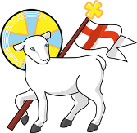
Year 2
St John the Baptist C of E Primary School
‘Creating new possibilities for our future, with compassion in our hearts and courage on our journey.’
Autumn 1 - Learning Overview
Learning Journey 1:
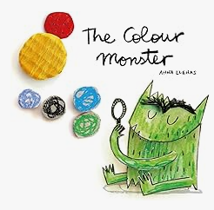
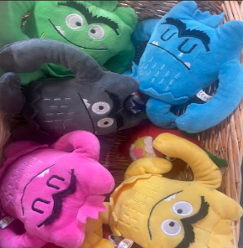
The Hook
The Colour Monster

Outcome: Descriptive writing.
Learning Journey 2 :
The Hook:
The Day the Crayons Quit
Outcome: A letter
What we will be teaching:
English:
A recap of phase 5 phonics to support spellings and an introduction to new spelling rules, including adding suffixes.
Writing different sentence types including questions, exclamatory sentences and using conjunctions in compound sentences.
Using adjectives for description and writing expanded noun-phrases.
Maths:
Number and place value, thinking about numbers up to 100.
Addition and subtraction including using different contexts; e.g money.
Geography:
Identifying the United Kingdom, its countries and surrounding seas.
Science:
Forces: Investigating pushes and pulls.
ART/DT:
Thinking about primary colours and secondary colours.
Creating a moving picture
RE:
Creation: Who made the world.
Computing:
Technology in the classroom
PE:
Gymnastics.
Attack, defend and shooting skills.
Messages to parents:
Thank you for a warm welcome back to the new academic year.
The Year 2 team is looking forward to working with your children, and you, to ensure the best outcomes for their learning.

