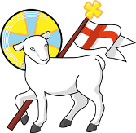
Year 3
St John the Baptist C of E Primary School
‘Creating new possibilities for our future, with compassion in our hearts and courage on our journey.’
Autumn 1 - Learning Overview
The Hook
Fantastic Mr Fox
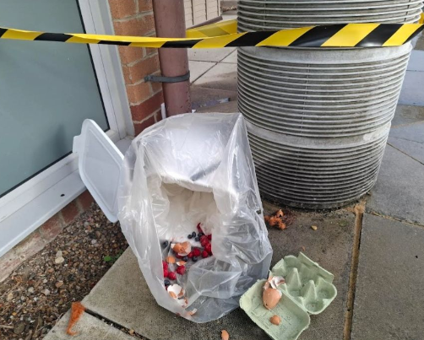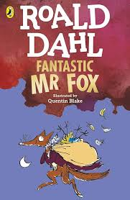
Outcome: Non Chronological report
Outcome: Poem
What we will be teaching:
English:
Recap of Year 2 grammar expectations including adjectives, prepositions, sentence forms
(command, statement, exclamation, questions)
Adverbs, apostrophes for possession.
Literary devices including alliteration, metaphor, simile and personification.
Maths:
Place value, addition, subtraction and problem solving using various written and mental strategies including numberline, partitioning, expanded method.
History/Geography:
Local study - How did our school get its name?
Science:
Magnets
ART/DT:
Printing and leavers and linkages
RE:
What does the creation story mean to Christians?
Computing:
Connecting computers
PE:
Gymnastics and Football
French:
Cultural understanding, greetings and responses.

Messages to parents:
Thank you for your warm welcome and support of us. We look forward to working with you to get the best outcomes for our children.

