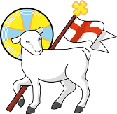
Year 4
St John the Baptist C of E Primary School
‘Creating new possibilities for our future, with compassion in our hearts and courage on our journey.’
Autumn 1 - Learning Overview
The Hook
The children used their inference skills and studied the Bayeux Tapestry which retold the story of the Battle of Hastings.
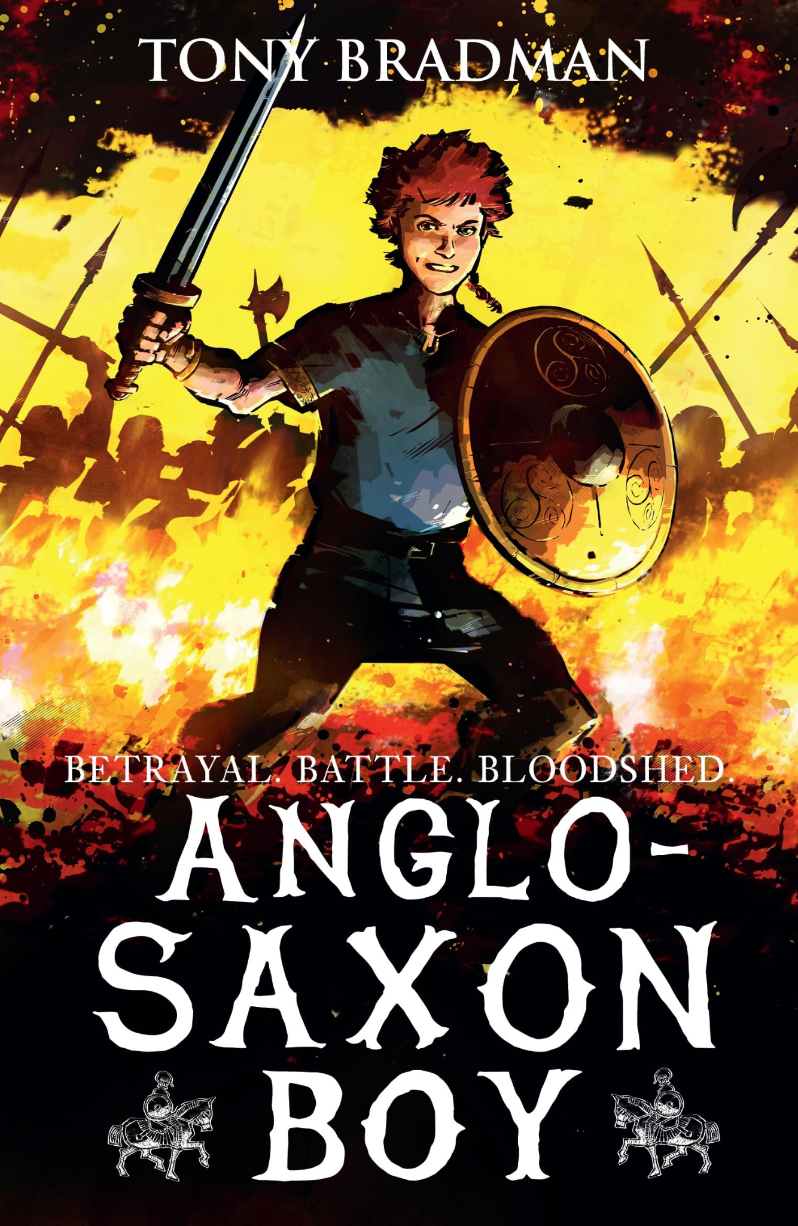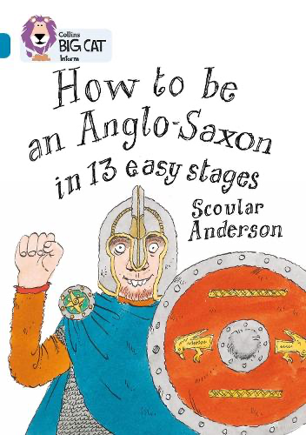
Learning journey 1: Anglo-Saxon Boy
Learning journey 2: How to be an Anglo-Saxon
What we will be teaching:
English:
Chapter for a narrative and non-chronological report
Recap of Year 3 skills, using high level adjectives, fronted adverbials, co-ordinating and subordinating conjunctions and direct speech
Maths:
Place value of numbers above 1000, negative numbers, rounding numbers to the nearest 10, 100 and 1000 and recap knowledge and strategies of addition and subtraction
History/Geography:
Anglo-Saxons
Science:
Mixtures and Solutions
ART/DT:
Paper Mache and painting skills
RE:
What does the creation story mean to Christians?
Computing:
Network and the internet
PE:
Tag rugby and gymnastics
French:
Cultural understanding, greetings and responses.
Messages to parents:
Thank you for a warm welcome back to the new academic year.

