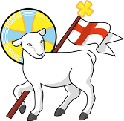
Year 5
St John the Baptist C of E Primary School
‘Creating new possibilities for our future, with compassion in our hearts and courage on our journey.’
Autumn 1 - Learning Overview
The Hook
- - Caution! This Book Contains Deadly Reptiles by Corey Tutt

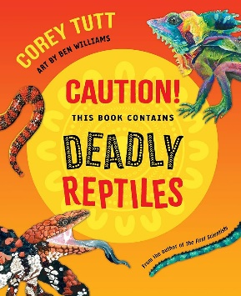

To kick off our lizard learning journey, the children explored our asphalt jungle (the KS2 playground) and discovered 9 species of different reptiles. They are using their discoveries to inspire the creation of their own new species.

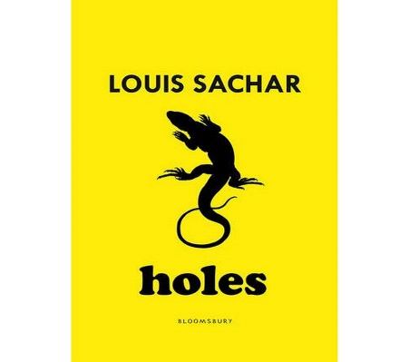

2 - Holes by Louis Sachar

To begin our learning journey on Holes, Miss Young will transform into one of the juvenile inmates sent to Camp Green Lake. The class will see the appalling living condition that Stanley, the protagonist of our story, will experience.
What we will be teaching:
English:
In Autumn 1 we are looking at selecting language for effect. The class will also practise their use of subordinate conjunctions to create complex sentences, and how to use relative pronouns with subordinates clauses to add detail to the sentences. The class will be applying their learning to a variety of writing outcomes including non-chronological reports, letters and diary entries.
Maths:
During this term we work through units on: number and place value, addition and subtraction (including length), multiplication and division (with areas and arrays) and fractions.
History/Geography:
This term there is a focus on Geography. Our topic is ‘Our Resourceful World’ which begins with exploring different countries in the atlas. We will then explore the resources of clean water, food and energy. Children will develop their understanding of the necessity for these resources and where in the world they come from, before evaluating if every country is equal.
Science:
Our unit is fossils, geographic time and classifications. The children have already been drawing upon their learning from Year 4 and have made exciting links to their RE topic this half term.

ART/DT:
This term the focus is on Art, specifically the skill of drawing. The children will be exploring a variety of mark making techniques to eventually create a detailed drawing inspired by their lizard research.
RE:
Creation - Creation or Science: conflicting or complementary? We will explore this question through developing children's understanding of the story Genesis 1. The children will then learn about cosmology and alternative beliefs, before answering our question at the end of the unit.
Computing:
Computing systems and networks. The class were instantly engaged with this unit when asked to apply their understanding of the systems on a bicycle.
PE:
Indoor PE is Gymnastics this half term. The children will be learning different positions, creating sequences in groups, as well as how to use a variety of apparatus safely. Outdoor PE is football. Each week will focus on a different skill like dribbling or passing before we begin to play matches as a class.
French:
- La Rentrée (Back to School) - Focus on a French Primary School
- French Culture - What defines culture and specifically French culture
- Fascinating Facts about France - What do we know already? What can we find out?
- French Spoken around the world - Only in France or other countries too?

Messages to parents:
Remember to check the St John’s jottings weekly for dates of upcoming events in school. This is emailed each Friday and is designed to keep our community up-to-date on important events in school.

Keep in Touch : year_5@stjohnthebaptistprimary.co.uk

