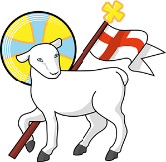
Year 6
St John the Baptist C of E Primary School
‘Creating new possibilities for our future, with compassion in our hearts and courage on our journey.’
Autumn 1 - Learning Overview

The Hook
The Diver’s Daughter by Patrice Lawrence
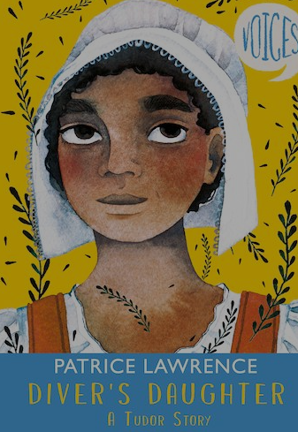
A modern mystery set in Tudor times
Can modern day forensics reveal the rogues in this story?
A Science investigation using disciplinary skills

What we will be teaching:
English:
We will be writing our own narrative. Describing using personification, Selecting our adjectives with precision, using relative clauses to add detail and thinking carefully about the sentence structures we use for impact.
Maths:
In Maths we will focus on place value and where decimals fit on the place value grid. We will explore negative numbers and rounding as well as Division and multiplication formal methods
History/Geography:
In History we will be exploring the Tudor monarchy and their role in British History and world events. We will also be learning about Tudor politics and lifestyles of different classes. In Geography we will make links with our local area and explore what Southampton and Portsmouth were like in Tudor times.
Science:
In science we will be recapping air and water resistance as well as learning about the circulatory system
ART/DT:
In art we will focus on one point perspective and sketching techniques. In DT we will explore food technology ( Tudor recipes)
RE:
Creation or Science: conflicting or complementary?
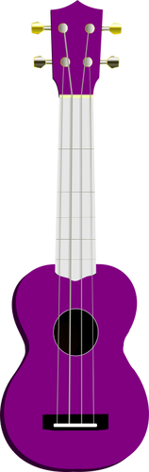
Computing:
We will be looking at algorithms and sharing information
PE:
Tag Rugby and Gymnastic sequences
French:
French culture and facts about France
Messages to parents:
Remember to check the St John’s jottings weekly for dates of upcoming events in school. This is emailed each Friday and is designed to keep our community up-to-date on important events in school.
Keep in Touch : year_6@stjohnthebaptistprimary.co.uk

