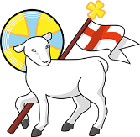
Year 4
St John the Baptist C of E Primary School
‘Creating new possibilities for our future, with compassion in our hearts and courage on our journey.’

Autumn 2 - Learning Overview
The Hook
The children used their inference skills and were given a variety of clues to help them conclude what they will be writing about and in what writing style.
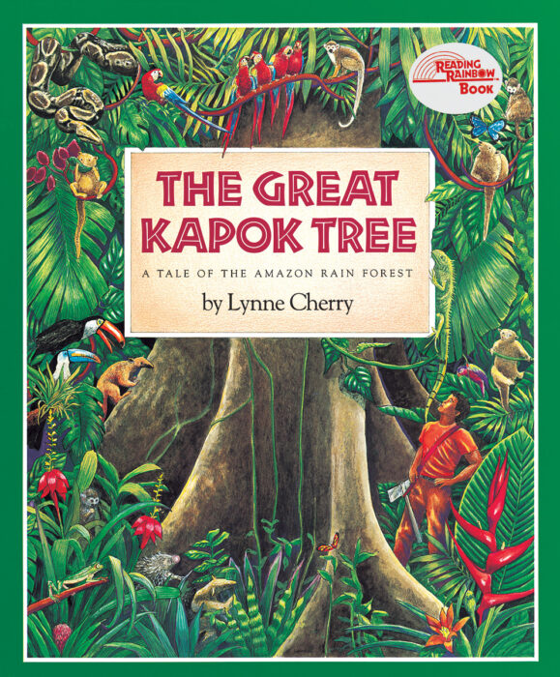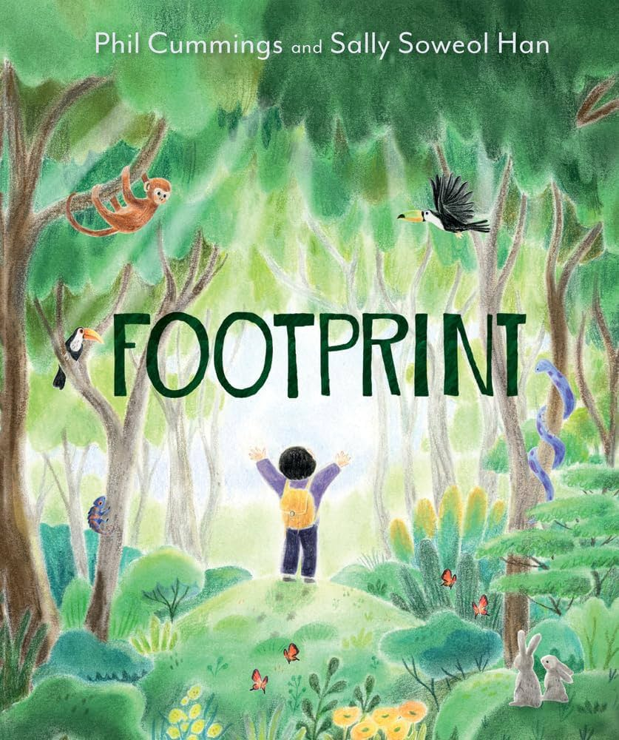
Learning journey 1: The Great Kapok Tree
Learning journey 2: Footprint
What we will be teaching:
English:
Learning journey 1: The children are focusing on writing a persuasive letter to stop deforestation. They will be studying how to use rhetorical questions, formal writing, present tense and emotive language.
Learning journey 2: Otter class will be reviewing previous skills taught last term around writing a narrative. The children will work again towards using inverted commas to indicate direct speech, different sentence openers and a variety of noun phrases to enhance the quality and style of their writing.
Maths:
The children will be recapping knowledge on Fractions and thinking about counting up and down in tenths and hundredths and building their understanding of their relationship between the two. Year 4 will also be moving onto Geometry and looking at 2D shape properties and their angles. Finally, Otter class will also be looking at Measurement and how to convert m into km, g into kg and solving a variety of word problems.
History/Geography:
Rainforest
Year 4 will be looking at the different rainforests located around the world and what type of climate it has. They will also be looking at the impact deforestation has on that environment and study the biodiversity found there.
Science:
Digestive system
Otter class will be labelling the different organs related to our digestive system and the impact diet has on our body. We will also be studying different types of teeth and how that contributes to our diet. We will also, finally, be planning and completing an investigation on the impact different types of drinks have on our teeth, using marble chips to represent our teeth.
ART/DT:
Water colours
Year 4 will be practising and exploring colour focusing on how we can create tint and shade using white, black and by controlling the amount of water we use. We will also be focusing on the colour wheel and how we can create secondary and tertiary colours. As a final piece, we will be producing a rainforest scenery using water colours and techniques we have practised.
RE:
Incarnation: What is the Trinity?
Computing:
Programming: Audio
PE:
Outdoor: Basketball
Indoor: Dance
French:
Numbers (1-20), colours, classroom objects and animals.
Messages to parents:
Thank you for your understanding last term due to my absence. I am thrilled to be back with Otter class and to continue to support them with their journey through St Johns in Year 4.

