




St John the Baptist Church of England
Primary School

Collective Worship Policy

Approval by:  Review Frequency:  Last Reviewed:  Next Review Due: |  | Full Governing Body  Annually  September 2025  September 2026
Review Approved:
- On behalf of the Governing Body -

Rebecca Livings – Headteacher

Date Approved: October 2025

‘Through our core Christian values, we aim to create new possibilities for our future, with compassion in our hearts and courage on our journey.’

Courage, Compassion, Creativity



Introduction

This policy is an agreed statement of the values and aims of collective worship at St John the Baptist Primary School. It has been prepared by the governors and headteacher with assistance from other staff and diocesan advisers. Collective worship is valued as a central aspect of the life of our church school, through which children grow spiritually, emotionally, morally and culturally.

Legal status of collective worship
In a Church of England school, worship must be in line with the trust deed of the school and will reflect the traditions of the Church of England, i.e. the Anglican tradition.

The right of withdrawal
Parents have a legal right to withdraw their child from acts of worship. We ask for this to be discussed with the headteacher so the exact nature of worship is understood by the parents before this becomes a permanent arrangement. If parents nevertheless require their child to be withdrawn from collective worship, they will be required to advise the school on what alternative spiritual activity they wish their child to engage in during this time. Please be aware that this does not mean that the children will be exempt from the Christian ethos of the setting which underpins our teaching, learning and relationships.

Worship in our school should:

As worship:
- Be at a level to enable children and adults to explore their own understanding of God within a Christian framework
- Explain and promote the core Christian values of the setting
- Have Integrity as acts of Anglican worship whilst being invitational, inclusive and inspirational
- Be based on Biblical text or themes
- Be central in importance to the life of our school community, which is part of a wider community that embraces the whole world
- Mark the seasons and festivals of the Christian year
- Develop understanding of Anglican traditions such as the lighting of a candle or use of a cross

For people:
- Develop personal spirituality within the setting community through a range of experiences including individual and collective prayer
- Celebrate the God given gifts and talents of individuals
- Make a significant contribution to the overall spiritual, moral, social and cultural development of members of the school community


Aims of our worship
- To promote the joy of worship as engaging, inspiring, inclusive and transformative
- To develop spirituality, morality, social and cultural values
- To give an opportunity to experience the meaning and significance of faith as revealed in the Bible
- To understand, celebrate and develop children’s knowledge of Christian beliefs, celebrations, traditions and religious festivals in the Anglican Church’s year
- Facilitate a deeper understanding of the Christian story narrative, from creation to the present day
- To appreciate that people, cultures and beliefs differ and to demonstrate respect, tolerance and generosity towards them
- To develop young children’s sense of self-worth and to provide opportunities to celebrate achievements.
- To develop a caring attitude to others and a sense of community and loyalty
- To provide opportunities for children to plan, lead, contribute to, monitor and evaluate collective worship
- To invite clergy of the parish, other lay members of the parish and other Christian leaders in the community [as are acceptable to the parish church] to lead worship weekly

How we achieve our aims
We aim to promote collective acts of worship, which are rich, meaningful experiences that are appropriate and significant to the pupil’s needs, age, development and interest by:
- Creating a sense of occasion and reverence
- Providing opportunities that develop pupil’s awareness of what is beautiful, good, wonderful, awesome and puzzling in life experience
- Arranging worship at different places when possible, different times with different people and groupings, involving all members of the setting community at some time
- Planning and linking themes which focus on a particular idea/concept, i.e. the liturgical year; festivals and celebrations, our Christian values
- Using a wide range of resources, artefacts (from religious and secular sources), music, art, drama and external visitors to engage children’s interest
- Encouraging children to participate and experience different styles of worship, e.g. prayer, praise, silence, rituals, and become familiar with the language of worship, Biblical readings and liturgy
- Providing opportunities for children and adults to reflect, contemplate their own thoughts, feelings and beliefs
- Using the centrality of prayer – personal silent prayer, personal shared prayers, collective prayers, writing prayers; all prayer will be invitational
- Involving young children and members of the wider community to participate in collective worship and activities within the parish
- Presenting and creating displays that promote and enhance spiritual ideas, thoughts and questions
- Through providing a peaceful environment enabling stillness, reflection and prayer as well as times for a joyous environment with singing, music, dance, drama, etc

Central attributes of an act of worship
The setting will endeavour to fulfil the following ‘central attributes’ of worship:
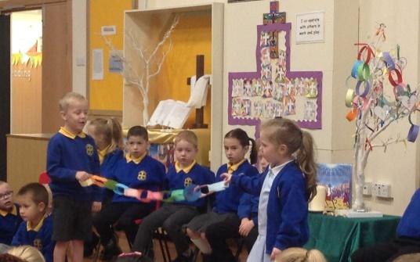
Gathering Making worship a special time of the day.
Engaging Using the best available techniques to stimulate interest in the content.
Responding Ensuring there is time and opportunity for individual, group reflection and thought, so those attending can respond in a variety of ways.
Sending Summarising the worship in a meaningful short message used to create an opportunity for those attending to implement the ideas covered and to conclude the worship.

Collective worship should be planned systematically, so that there is continuity, variety and clear focus on Christian stories, values and traditions. Worship is led by a variety of people that include school staff, children, representatives from the parish church and members of other Christian denominations.

The centrality of prayer
During the collective worship there will be a time for response and reflection, to ponder on a question, statement or thought. This may also be reflected in an invitational prayer, offered spontaneously by a child or adult, read out or recited. This prayer can be displayed and used in class and setting reflective areas so that:

- Children understand the nature and purpose of prayer
- Children understand the part prayer may play in their lives and the life of the setting community
- Prayer contributes to the spiritual development of individuals and the whole setting community
- There will also be appropriate opportunities for prayer and other worship activities, including reflection, outside of collective worship

The school has a ‘reflective area’ to engage children in prayer, as well as designated special spaces in classrooms and around the school.

Planning and Organisation

Planning
Collective worship is planned systematically so that there is continuity, variety and clear focus on Christian beliefs and festivals.

Organisation
Monday | Whole School Worship led by a senior leader
Tuesday | Whole School Worship led by St John the Baptist Church
Wednesday | Phase Worship led by teachers
Thursday | Class Worship led by staff
Friday | Whole School Celebration Worship led by a senior leader

Resources
The setting has resources available to support collective worship and these are stored in the hall and the headteacher’s office this includes artefacts and music resources. Electronic resources can be found on the school network on the shared drive.

Communication
The school will communicate with parents our collective worship themes via newsletters and display boards.

Parental involvement
Parents are actively encouraged to participate in collective acts of worship when possible including church services and celebration.
Parents will be kept informed about the themes of worship at the school through (for example, weekly newsletters, the collective worship section of the school website)

Responsibilities
The normal expectation within our church school is for all staff to view collective worship as an important part of their own well-being and spiritual development as human beings. The school will endeavour to timetable staff so all have an opportunity to attend regularly. Staff will received collective worship training from the Diocesan Education Team with regular updates.
At interview all applicants are informed that the setting holds acts of collective worship that promote the Christian ethos and values of the school. The normal expectation will be that staff will participate in and lead collective worship. The school welcomes offers from any member of staff who feels confident to lead worship.
The headteacher is responsible for co-ordinating the programme of induction and training for staff.
The headteacher is responsible for planning and organising collective worship.

Monitoring and evaluation
Monitoring and evaluation of collective acts of worship is undertaken by governors and key staff. This process supports the school’s self-evaluation and staff development and appraisal. All leaders of collective worship are asked to evaluate continuously, reflect after every worship, to develop and improve their practice.

Review
This policy should be reviewed annually.
References to ‘parish’ refer to the local parish church to which the school is linked.

Appendices
APPENDIX 1a - Collective worship observation form and 1b Observation pointers
APPENDIX 2 - Liturgical Colours and seasons of the Christian year
(Note: This is for reference, a calendar for each year, showing the dates of festivals and times when liturgical colours are changed is sent out by the diocese).

APPENDIX 1a Collective worship observation form
Setting ___________________________________________________________________________________Leader: ____________________________________ Observer: ____________________________________
Worship Theme: _____________________________ Time Allocation: _________________ minutes

Collective worship in Church of England Settings should at its simplest create a time and space where we can come closer to God and God can come closer to us.

CRITERIA | ASPECT | COMMENT
Central Attribute 1  Gathering | Is there a real sense of a very special time in the day?  Immediate impact, relevant, welcoming, stimulates interest or dull, uninteresting, lacks focus.
Central attribute 2  Engaging | Does the worship leader capture the attention of the children and staff so they become actively engaged in the content?  Excellent - well expressed, stimulating or poor communicator  Convincing, enthusiastic, warm or lack of rapport.
Central attribute 3  Responding | Does the leader allow for a response from the children and adults – whether active or passive, noisy or quiet?
Central attribute 4  Sending | Does the leader send us out with a clear “thought for the day” something that changes our behaviour in some way?  Clear summary, learners given opportunity to reflect or unclear what the message was.
In addition
Content | Clear Christian / Biblical content and teaching.  Woolly, lack of structure, largely secular.
Summary
APPENDIX 1b Observation form pointers for consideration - NB not a check list.
Collective worship in Church of England Settings should at its simplest create a time and space where we can come closer to God and God can come closer to us.
Gathering | Music (entry/exit) | appropriate / random, linked to theme, creates atmosphere, delivers a message
Gathering | Welcome | whether greetings exchanged and introduction made
Gathering | Atmosphere | extent to which act of worship is portrayed as special and important
Engaging | Focus | table, cloth, Bible, cross, candle, artefacts ICT / Visual / drama provides appropriate, linked relevant visual/factual information
Engaging | Awe and Wonder | sense given of marvel of world / creation
Engaging | Conviction | extent to which message is clear and compelling or words lack power and appear as paying lip service
Responding | Participation | extent to which learners involved in responding, partner talk, opportunities for some to participate directly
Responding | Singing | whether there was appropriate hymn / song, quality, enthusiasm of participation
Responding | Reflection | learners given time to pause and reflect
Responding | Prayers | extent to which prayers are appropriate and learner friendly, whether learners are invited to respond
Sending | Dismissal | whether the person takes charge, smiles, engages with some learners, says ‘thank you’
Other aspects | Distinctively Anglican | clear reference is made to the Bible and Anglican Christian teaching and belief e.g. the Trinity - God, Jesus and Holy Spirit
Other aspects | Inclusive | the worship reflects the multi faith / cultural nature of the world and feels inclusive to those of other and no faith
Other aspects | Dynamism & Theatricality | was it a performance rather than an act of worship
Other aspects | Open or Closed | does the leader give room for the children to build their own meanings / connections / links or are they told what to think?
Other aspects | Age Appropriateness | are the language, concepts, ideas appropriate? Is it meaningful for the youngest yet appropriate for the oldest?

APPENDIX 2
Liturgical Colours and seasons of the Christian year

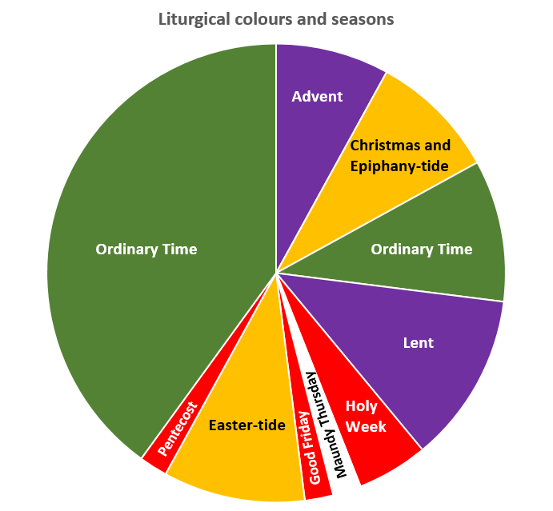

Season | Liturgical Colour | Description
Advent | Purple | The period covering the four Sundays before the 25th December:  Period of preparation for Christmas.
Christmas-tide | White or Gold | 25th December to 2nd February
Gap Between | Green | Gap of Green until Tuesday before Ash Wednesday
Lent | Purple | The 40 days of preparation for Easter
Maundy Thursday | White or Gold | The Last Supper
Good Friday | Red | The Crucifixion
Easter-tide | White or Gold | Easter Day until Pentecost
Pentecost | Red | 50 Days after Easter (lasts a week)
The Rest of the Year | Green | From Pentecost to Advent
Meaning of the colours | Purple | Penitence, preparation
Meaning of the colours | White or Gold | Joy, purity, innocence, Saints who are not martyrs
Meaning of the colours | Red | Fire & Blood, therefore Holy Spirit and Martyrdom
Meaning of the colours | Green | Everything else
In some places | Blue | The Blessed Virgin Mary
In some places | Pink | Mothering Sunday (4th in Lent) and 3rd in Advent
There are different versions of the colours used.
Please consult your parish for the colours used locally.
St John the Baptist Church of England Primary School

