
St John the Baptist C of E Primary
School
Governor Annual Report –2025
‘Creating new possibilities for our future, with compassion in our hearts and courage on our journey.’

On behalf of the Governing Body I welcome all new pupils and parents to the school and thank all of you who have been associated with the school over the past year for your continuing support.
The last year has been challenging for all associated with the school, but I am pleased to report that those issues have been addressed by all concerned and the school is once again in a strong position and will continue to build on its strengths.
Throughout all of the above the prime consideration of the Governors was the wellbeing of the pupils and staff. Whilst, at times, this was taxing, everyone involved should be truly proud of their combined achievement.
It is a credit to all involved that in November 2025 the Statutory Inspection of Anglican and Methodist Schools (SIAMS) was undertaken and the outcome was highly successful, recognising the strength of the Christian ethos, quality of collective worship and the way the values are embedded across the school.
Role of the Governing Body
The Governing Body is the strategic lead within the school and it plays a key role in ensuring that every child gets the best education possible in a safe environment. It has three main tasks:
- Ensuring there is a clear vision, ethos and direction of travel
- Holding the headteacher to account for the educational performance of the pupils and the leadership of the staff
- Overseeing the financial performance of the school and ensuring that money is well spent
The Governing Body does not have involvement in the day to day running of the school, that is the responsibility of the headteacher.
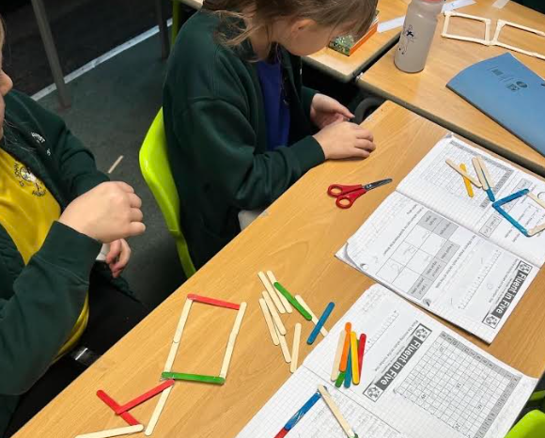
The Board is made up of individuals who give their time and skill to support the school. The headteacher and Parish minister are default members. School teaching staff elect one of their number to sit on the Board. Two members are elected from the Parents of children attending the school. Two members are nominated by the Portsmouth Diocese and one by the Local Authority. Finally, up to five individuals are co-opted. All decisions taken by the Board are its joint responsibility. Members have specific responsibilities assigned to them such as Finance or Training.
The Board meets seven times in the year to review the school policies, performance and progress, finances and attendance. In addition, many of the members visit the school in order to undertake the specific role that they hold. These visits present opportunities to speak with pupils and staff and gain a feel for the community life, what is going well and what issues there may be.
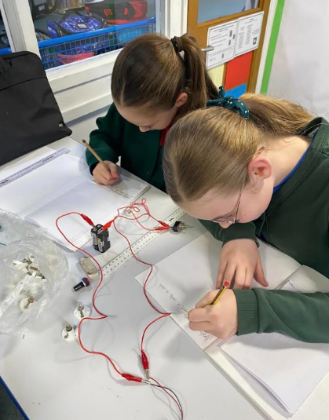
All Governors attend training to assist and guide them in their roles and once each year the whole Board gathers together for a specific joint training session to update their knowledge and skills to enable them to carry out their roles as effectively as possible.
Financial Performance
The academic year 2024/25 was the last year of the school transition from a forty-five pupil class size to a thirty pupil class size. This transition took place over six years and for each of those years the income of the school fell in line with the reducing number of pupils. The final year of this transition process is always a difficult one to manage and can often result in a reduction in income of tens of thousands of pounds. A budget deficit in that year is not uncommon.
It was the case that the school did trade at a deficit in 2024/25 which was greater than the surplus that it had at the beginning of the year. The in-year deficit was less than had been budgeted but still meant that the budget prepared for the current year was very carefully structured to produce a surplus to reduce the brought forward deficit. With three months to go in the financial year it is pleasing to see that the ongoing surplus is greater than was budgeted and will substantially reverse the deficit brought forward.
As with all other schools there is enormous pressure on budgets and it is likely this will continue in future years. The Board has the clear objective of ensuring the school will operate within its financial boundaries and the careful management of expenditure and maximising income is a key objective.
The Board is very grateful for the financial support and assistance that the Parents and Friends of St Johns (PAFS) continue to provide and also for the role that many individuals have played with gifts, materials, and donations.
Academic achievement
Once again, the Year 6 children and staff worked extremely hard during the year to achieve the SATs results that they did. All accepted the challenge and performed at or close to their expected achievement level. Overall, the results were at or close to those predicted with some exceeding the predicted level. The results achieved have been carefully analysed by the new Headteacher and strategies developed and implemented to do even better in the current and future years.
School estate
During the summer holidays work commenced on the redevelopment of the Year R play area at the northern end of the building. This is a fairly complex development as it requires the rebuild and settlement of a large grass bank area on which the play area will be constructed. The works are planned to be completed over the Christmas break after the grass bank has properly settled. Over the Christmas period the school boilers are being replaced with the latest technology to provide a warm and controlled environment for all to learn in.
Over the summer holiday period the Headteacher assisted by staff and many helpers undertook an internal refresh to almost the entire school including, painting, new carpeting and decluttering. This included the fitting out of the Sensory Room which is being enjoyed by many children. Staff and children returned after the holiday period to an almost unrecognisable environment in which to start or recommence their education.
A huge thankyou to all who gave their time and resources to undertake this work.
It is likely that the redevelopment of the Morgans Yard site to provide eighty new houses and some commercial units will commence in January 2026. The Board has been liaising with the developer since July 2025 to seek to ensure that the work does not negatively impact the school life during the work phase and also to identify areas where they are able to work together for mutual benefit.
How can you become involved with the school?
The school is an integral part of the Waltham Chase, Shedfield and Shirrel Heath communities. As a member of one of those community groups the school will welcome you to work with it for the good of our children. Some ways that you may be able to do that are:
Join the Parents and Friends of St John’s (“PAFS”) group and participate in and help with events that they organise to provide much welcome financial assistance to the school. By joining you also get to meet like-minded parents with a common interest and have some fun.
Consider helping the school with a financial donation or sponsorship. Even though the school is publicly funded there is always something else that it needs and past financial donations have funded upgrades to the school technology for the benefit of all children. If you are not able to help financially then consider donating some of your skills or time which will always be welcome.
Become a Governor of the school and help in overseeing the development and future of it.
You are able to find out how to go about helping in any of the above ways by contacting the school office which will point you in the right direction.
In closing may I thank everyone who has helped the school in any way during the past year. Your contributions will have helped and positively impacted the lives of everyone at the school.
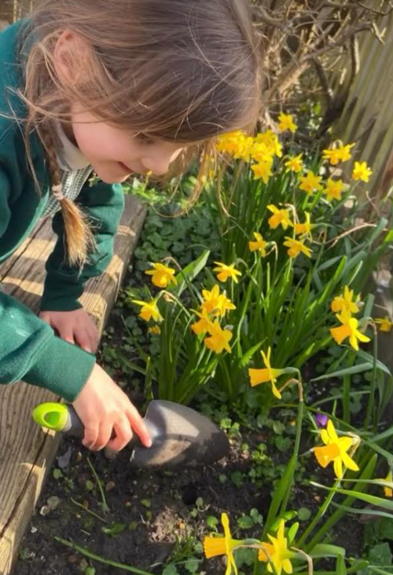
Best regards,

Paul Quigley
Chair of the Governing Board

