
St John the Baptist Church of England
Primary School

Allergen and Anaphylaxis Policy
2026 - 2029

Approval by:  Review Frequency:  Last Reviewed:  Next Review Due: |  | Full Governing Body  3 Years  February 2026  February 2029
Approved by the Governing Body
Rebecca Livings – Headteacher

Date Approved: February 2026

‘Through our core Christian values, we aim to create new possibilities for our future, with compassion in our hearts and courage on our journey.’

Contents
Statement of intent 3
1. Legal framework 3
2. Definitions 3
3. Roles and responsibilities 4
4. Food allergies 7
5. Food allergen labelling 8
6. Animal allergies 8
7. Seasonal allergies 8
8. Adrenaline auto-injectors (AAIs) 9
9. Access to spare AAIs 10
10. School Visits 11
11. Medical attention and required support 11
12. Staff training 12
13. In the event of an allergic reaction/anaphylaxis 12
Appendix One: Allergy Declaration Form 16

Statement of intent
St John the Baptist Primary School strives to ensure the safety and wellbeing of all members of the schools’ community. For this reason, this policy is to be adhered to by all staff members, families and pupils, with the intention of minimising the risk of anaphylaxis occurring whilst at school.
In order to effectively implement this policy and ensure the necessary control measures are in place, parents/carers are responsible for working alongside the school in identifying allergens and potential risks, to ensure the health and safety of their children.
The school does not guarantee a completely allergen-free environment; however, this policy will be utilised to minimise the risk of exposure to allergens, encourage self-responsibility, and plan for an effective response to possible emergencies.

1. Legal framework
This policy has due regard to all relevant legislation and guidance including, but not limited to, the following:
- Children and Families Act 2014
- The Human Medicines (Amendment) Regulations 2017
- The Food Information (Amendment) (England) Regulations 2019 (Natasha’s Law)
- Department of Health (2017) ‘Guidance on the use of adrenaline auto-injectors in schools’
- DfE (2015) ‘Supporting pupils at school with medical conditions’
- DfE (2025) ‘Allergy guidance for schools’
This policy will be implemented in conjunction with the following school policies and documents:
- Health and Safety Policy
- Policy for the Administration of Medicines
- Supporting Pupils with Medical Conditions Policy
- Educational Visits Policy

2. Definitions
For the purpose of this policy:
Allergy – is a condition in which the body has an exaggerated response to a substance. This is also known as hypersensitivity.
Allergen – is a normally harmless substance that triggers an allergic reaction for a susceptible person.
Allergic reaction – is the body’s reaction to an allergen and can be identified by, but not limited to, the following symptoms:

- Hives
- Generalised flushing of the skin
- Itching and tingling of the skin
- Tingling in and around the mouth
- Burning sensation in the mouth
- Swelling of the throat, mouth or face
- Feeling wheezy
- Abdominal pain
- Rising anxiety
- Nausea and vomiting
- Alterations in heart rate
- Feeling of weakness

Anaphylaxis – is also referred to as anaphylactic shock, which is a sudden, severe and potentially life-threatening allergic reaction. This kind of reaction may include the following symptoms:
- Persistent cough
- Throat tightness
- Change in voice, e.g. hoarse or croaky sounds
- Wheeze (whistling noise due to a narrowed airway)
- Difficulty swallowing/speaking
- Swollen tongue
- Difficult or noisy breathing
- Chest tightness
- Feeling dizzy or faint
- Suddenly becoming sleepy, unconscious or collapsing
- For infants and younger pupils, becoming pale or floppy

3. Roles and responsibilities
The Governing Body is responsible for:
- Ensuring that policies, plans, and procedures are in place to support pupils with allergies and who are at risk of anaphylaxis and that these arrangements are sufficient to meet statutory responsibilities and minimise risks.
- Ensuring that the school’s approach to allergies and anaphylaxis focuses on, and accounts for, the needs of each individual pupil.
- Ensuring that staff are properly trained to provide the support that pupils need, and that they receive allergy and anaphylaxis training at least annually.
- Monitoring the effectiveness of this policy and reviewing it on a three-yearly basis, and after any incident where a pupil experiences an allergic reaction.
The Headteacher is responsible for:
- The development, implementation and monitoring of the Allergen and Anaphylaxis
Policy.
- Ensuring that parents are informed of their responsibilities in relation to their child’s allergies.
- Ensuring that all relevant risk assessments (e.g. to do with food preparation) have been carried out and controls to mitigate risks are implemented.
- Ensuring that all designated First Aiders are trained in the use of adrenaline autoinjectors (AAIs) and the management of anaphylaxis (via 3-yearly Medical Conditions Awareness training)
- Ensuring that all staff members are provided with information regarding allergic reactions and anaphylaxis, including the necessary precautions and how to respond – for teachers receiving children with an AAI into their class, this will also be discussed during class handover prior to the start of the school year.
- Ensuring that catering staff are aware of pupils’ allergies and act in accordance with the school’s policies regarding food and hygiene, including this policy.
- Ensuring that catering staff are aware of any pupils’ allergies which may affect the school meals provided.

The Admin Team is responsible for:
- Ensuring that there are effective processes in place for medical information to be regularly updated and disseminated to relevant staff members, including supply and temporary staff (access to Arbor / orange bags).
- Seeking up-to-date medical information about each pupil with allergies via a medical form sent to parents on an annual basis in September.
- Contacting parents for required medical documentation regarding a child’s allergy.
- Ensuring that the necessary staff members are informed about pupils’ allergies.
- Understanding the action to take and processes to follow in the event of a pupil going into anaphylactic shock and ensuring that this information is passed onto staff members.
All staff members are responsible for:
- Acting in accordance with the school’s policies and procedures at all times.
- Attending relevant training regarding allergens and anaphylaxis.
- Being familiar with and implementing pupils’ individual healthcare plans (IHCPs) as appropriate.
- Responding immediately and appropriately in the event of a medical emergency.
- Reinforcing effective hygiene practices, including those in relation to the management of food.
- Promoting hand washing or sanitising before and after eating.
- Monitoring, as far as possible, all food supplied to pupils by both the school and families, including snacks, ensuring food containing known allergens (or a possible contamination warning) is not provided.
- Ensuring that pupils do not share food and drink in order to prevent accidental contact with an allergen.
- Ensuring that any necessary medication is out of the reach of pupils but still easily accessible to staff members.
- During outdoor activities, ensuring that any necessary medication is brought outside with the class for ready access (e.g. PE, outdoor learning, educational visits).
- Liaising with the school’s admin team and pupils’ parents/carers to ensure the necessary control measures are in place.

The Catering Supervisor is responsible for:
- Monitoring the food allergen log and allergen tracking information for completeness.
- Reporting any non-conforming food labelling to the supplier, where necessary.
- Ensuring the practices of kitchen staff comply with food allergen labelling laws and that training is regularly reviewed and updated.
- Recording incidents of non-conformity, either in allergen labelling, use of ingredients or safe staff practice, in an allergen incident log.
- Acting on entries to the allergen incident log and ensuring the risks of recurrence are minimised.
Kitchen staff are responsible for:
- Ensuring they are fully aware of the rules surrounding allergens, the processes for food preparation in line with section 4 and section 5 of this policy, and the processes for identifying pupils with specific dietary requirements.
- Ensuring they are fully aware of whether each item of food served contains any of the main 14 allergens, as is a legal obligation, and making sure this information is readily available for those who may need it.
All parents/carers are responsible for:
- Notifying the school office of the following information, via the form in Appendix One:
− Their child’s allergens
− The nature of the allergic reaction
− What medication to administer
− Specified control measures and what can be done to prevent the occurrence of an allergic reaction
- Keeping the school up-to-date with their child’s medical information.
- Providing written consent for the use of a spare AAI, via the form in Appendix One.
- Providing the school with up-to-date emergency contact information.
- Providing the school with written medical documentation, including instructions for administering medication as directed by the child’s doctor.
- Providing the school with any necessary medication, in line with the procedures outlined in the Supporting Pupils with Medical Conditions Policy.
- Communicating to the school any specific control measures which can be implemented in order to prevent the child from coming into contact with the allergen.
- Providing the school, in writing, any details regarding the child’s allergies.
- Working alongside the school to develop an IHCP to accommodate the child’s needs, as well as undertaking the necessary risk assessments.
- Signing their child’s IHCP, where required.
- Acting in accordance with any allergy-related requests made by the school, such as not providing nut-containing items in their child’s packed lunch.
- Ensuring their child is aware of allergy self-management, including being able to identify their allergy triggers and how to react (as far as possible, dependent on their age).
- Providing a supply of ‘safe’ snacks for any individual attending school events.
- Raising any concerns they may have about the management of their child’s allergies with the School admin team.
- Ensuring that any food their child brings to school is safe for them to consume.
- Liaising with staff members, including those running breakfast and afterschool clubs, regarding the appropriateness of any food or drink provided.
All pupils are responsible for:
- Ensuring that they do not exchange food with other pupils.
- Avoiding food which they know they are allergic to, as well as any food with unknown ingredients.
- Being proactive in the care and management of their allergies.
- Notifying a member of staff immediately in the event they believe they are having an allergic reaction, even if the cause is unknown.
- Notifying a member of staff when they believe they may have come into contact with something containing an allergen.
- Learning to recognise personal symptoms of an allergic reaction.
- Keeping necessary medication in the agreed location.
- Developing greater independence in keeping themselves safe from allergens.
- Notifying a staff member if they are being bullied or harassed as a result of their allergies.

4. Food allergies
Parents will provide the school with a written list of any foods that their child may have an adverse reaction to, as well as the necessary action to be taken in the event of an allergic reaction, such as any medication required. This should be done on the annual medical form sent out by the school, or as soon as an allergy is discovered.
Information regarding all pupils’ food allergies will be collated, indicating whether they consume a school dinner or a packed lunch. Parents will also provide this information directly to the school’s catering service, Chartwells | The UK’s Leading School Catering Company if they wish to have school lunches.
When making changes to menus or substituting food products, the school’s catering service, Hampshire Catering (and the school, if emergency food provision is required in the case of kitchen equipment failure) will ensure that pupils’ special dietary needs continue to be met by:
- Checking any product changes with all food suppliers
- Asking caterers to read labels and product information before use
- Using the Food Standards Agency’s allergen matrix to list the ingredients in all meals.
- Ensuring allergen ingredients remain identifiable.
Kitchen staff will have a full list of allergens and will avoid using them within the menu where possible.
The school will ensure that there are always dairy- and gluten-free options available for pupils with allergies and intolerances.
Where a pupil who attends the school has a nut allergy, the school will:
- Confirm that the school’s catering service eliminates nuts, and food items with nuts as ingredients, from meals as far as possible
- Request that food items containing nuts not be brought onto school premises.
- Maintain an allergy log and ensure staff know where it can be located.
To ensure that catering staff can appropriately identify pupils with dietary needs, a record of pupils with food allergies will be kept in a file available in the kitchen area – this includes the child’s photograph (to aid catering service supply staff).
All food tables will be disinfected before and after each lunchtime session. Cleaning fluid will be used.
The chosen catering service of the school is responsible for ensuring that the school’s policies and government legislation are adhered to at all times, including those in relation to the preparation of food, taking into account any allergens.
Learning activities which involve the use of food, such as Design and Technology lessons, will be planned in accordance with pupils’ IHCPs, taking into account any known allergies of the pupils involved.

5. Food allergen labelling
The school does not currently provide any pre-packed food goods.
However, the school will adhere to new allergen labelling rules for prepacked food goods if such goods are provided, in line with the Food Information (Amendment) (England) Regulations 2019, also known as Natasha’s Law.
The school will ensure that any pre-packed food is labelled accurately, that food is never labelled as being ‘free from’ an ingredient unless staff are certain that there are no traces of that ingredient in the product, and that all labelling is checked before being offered for consumption.
The relevant staff, e.g. kitchen staff, will be trained by the catering provider prior to storing, handling, preparing, cooking and/or serving food to ensure they are aware of their legal obligations.

6. Animal allergies
Pupils with known allergies to specific animals will have restricted access to those that may trigger a response.
In the event of an animal on either school site, staff members will be made aware of any pupils to whom this may pose a risk and will be responsible for ensuring that the pupil does not come into contact with the specified allergen.
The school will ensure that any pupil or staff member who comes into contact with the animal washes their hands thoroughly to minimise the risk of the allergen spreading.
A supply of antihistamine medication will be kept in the school office in case of an allergic reaction.

7. Seasonal allergies
The term ‘seasonal allergies’ refers to common outdoor allergies, including hay fever and insect bites.
Precautions regarding the prevention of seasonal allergies include ensuring that grass within the school premises is not mown whilst pupils are outside. All pupils with known grass pollen allergies should stay off the junior school field on the day that it is mown.
Pupils with severe seasonal allergies will be provided with an indoor supervised space to spend their break and lunchtimes in, avoiding contact with outside allergens.
Staff members, utilising information that may be received from parents/carers regarding pollen counts, will make a professional judgement as to whether a pupil with a severe seasonal allergy should stay indoors.
Pupils will be encouraged to wash their hands and not rub their eyes after playing outside.
Where a pupil with a known allergy is stung or bitten by an insect, medical attention will be given immediately.
Staff members will be diligent in the management of wasp, bee and ant nests on school grounds and in the school’s nearby proximity, reporting any concerns to the Headteacher.
The Headteacher is responsible for ensuring the appropriate removal of wasp, bee and ant nests on and around the school premises.

8. Adrenaline auto-injectors (AAIs)
Pupils who suffer from severe allergic reactions may be prescribed an AAI for use in the event of an emergency.
Under The Human Medicines (Amendment) Regulations 2017 the school is able to purchase AAI devices without a prescription, for emergency use on pupils who are at risk of anaphylaxis, but whose device is not available or is not working.
The school will purchase spare AAIs from a pharmaceutical supplier, such as the local pharmacy
The school will submit a request, signed by the Headteacher, to the pharmaceutical supplier when purchasing AAIs, which outlines:
- The name of the school.
- The purposes for which the product is required.
- The total quantity required.
The Headteacher, in conjunction with the School admin team, will decide which brands of AAI to purchase.
Where possible, the school will hold one brand of AAI to avoid confusion with administration and training; however, subject to the brands pupils are prescribed, the school may decide to purchase multiple brands.
The school will purchase AAIs in accordance with age-based criteria, relevant to the age of pupils at risk of anaphylaxis, to ensure the correct dosage requirements are adhered to. These are as follows:
- For pupils between 7.5Kg (1 stone 3 lbs) and 25Kg (3 Stone 13lbs) approx. under age 6: 0.15 milligrams of adrenaline – Green Labelled.

- For pupils/adults above 25Kg (3 Stone 13lbs) approx. aged 6-12: 0.3 milligrams of adrenaline – Yellow Labelled.
- Not to be used under 7.5Kg unless life threating.
- 999 will be called in all eventualities concerning use/potential use of AAI
The School will ensure that the AAIs are easily identified for appropriate ages.
Spare AAIs are stored as part of an emergency anaphylaxis kit, maintained by the School admin team, which includes the following:
2 AAIs – 1 for each age range
- Instructions on how to use the device(s)
- Instructions on the storage of the device(s)
- Manufacturer’s information
- A checklist of AAIs, identified by the batch number and expiry date, with monthly checks recorded.
- A note of the arrangements for replacing the AAIs
- A copy of the Allergy/Anaphylaxis Risk Register, including whether a spare AAI can be administered.
- An administration record
For pupils who have prescribed AAI devices, these are stored in class orange bags.
Spare AAIs are not located more than five minutes away from where they may be required. The emergency anaphylaxis kit can be found at the following location: Main school office
All staff have access to AAI devices, but these are out of reach and inaccessible to pupils – AAI devices are not locked away where access is restricted.
All spare AAI devices will be clearly labelled to avoid confusion with any device prescribed to a named pupil.
In line with manufacturer’s guidelines, all AAI devices are stored at room temperature, protected from direct sunlight and extreme temperature.
A named member of staff is responsible for maintaining the emergency anaphylaxis kit.
They conduct a monthly check of the emergency anaphylaxis kit to ensure that:
- Spare AAI devices are present and have not expired.
- Replacement AAIs are obtained when expiry dates are approaching.
The named member of staff is responsible for overseeing the protocol for the use of spare AAIs, its monitoring and implementation, and for maintaining the checklist of AAIs. Any used or expired AAIs are disposed of after use in accordance with manufacturer’s instructions.
Used AAIs may also be given to paramedics upon arrival, in the event of a severe allergic reaction, in accordance with section 13 of this policy.
A medical waste bin/sharps bin is utilised where used or expired AAIs are disposed of on the school premises.
Where any AAIs are used, the following information will be recorded on the AAI Record:
- Where and when the reaction took place
- How much medication was given and by whom

9. Access to spare AAIs
A spare AAI can be administered as a substitute for a pupil’s own prescribed AAI, if this cannot be administered correctly, without delay.
Spare AAIs are only accessible to pupils for whom medical authorisation and written parental consent has been provided – this includes pupils at risk of anaphylaxis who have been provided with a medical plan confirming their risk, but who have not been prescribed an AAI. See also the paragraph below:
(from section 13) In the event that a pupil without a prescribed AAI, or who has not been medically diagnosed as being at risk of anaphylaxis, suffers an allergic reaction, a designated staff member will contact the emergency services (999) and seek advice as to whether an AAI should be administered. An AAI will not be administered in these situations without contacting the emergency services.
Consent will be obtained as part of the introduction or development of a pupil’s IHCP.
If consent has been given to administer a spare AAI to a pupil, this will be recorded in their IHCP.
The school uses a register of pupils at risk from allergies/anaphylaxis, which indicates whether a spare AAI can be administered – this includes the following:
- Name of pupil
- Class
- Known allergens
- Risk factors for anaphylaxis
- Whether they have been prescribed an AAI (and if so, what type and dose)
- If they have been prescribed an AAI, whether parental consent has been given for use of the spare AAI (which may be of a different type than that prescribed).
Parents/carers are required to provide consent on an annual basis (in September) to ensure the register remains up-to-date.
Parents/carers can withdraw their consent at any time. To do so, they must write to the Headteacher. The School admin team check the register is up-to-date on a termly basis.

The School admin team will also update the register relevant to any changes in consent or a pupil’s requirements.
Copies of the register are held on Arbor and in orange class bags, which are accessible to all staff members.

10. School Visits
The Headteacher will ensure a risk assessment is conducted for each school visit to address pupils with known allergies attending. All activities on the school visit will be risk assessed to see if they pose a threat to any pupils with allergies and alternative activities will be planned where necessary to ensure the pupils are included.
The school will speak to the parents/carers of pupils with allergies where appropriate to ensure their co-operation with any special arrangements required for the visit.
A designated adult will be available to support the pupil at all times during a school visit.
If the pupil has been prescribed an AAI, at least one adult trained in administering the device will attend the visit. The pupil’s medication will be taken on the visit and stored securely – if the pupil does not bring their medication, they will not be allowed to attend the visit.
A member of staff is assigned responsibility for ensuring that the pupil’s medication is carried at all times throughout the visit.
A spare AAI will be taken on the visit and will be easily accessible at all times.
Where the venue or site being visited cannot assure appropriate food can be provided to cater for pupils’ allergies, the pupil will take their own food or the school will provide a suitable packed lunch.

11. Medical attention and required support
Once a pupil’s allergies have been identified, a meeting will be set up between the pupil’s parents/carers, the relevant classroom teacher, the School admin team and any other relevant staff members, in which the pupil’s allergies will be discussed and a plan of appropriate action/support will be developed.
All medical attention, including that in relation to administering medication, will be conducted in accordance with the Policy for the Administration of Medication and the Supporting Pupils with Medical Conditions Policy.
Parents/carers will provide the School with any necessary medication, ensuring that this is clearly labelled with the pupil’s name, class, expiration date and instructions for administering it.
Pupils will not be able to attend school or educational visits without any life-saving medication that they may have, such as AAIs.
All members of staff involved with a pupil with a known allergy are aware of the location of emergency medication and will be informed of the necessary action to take in the event of an allergic reaction.
Any specified support which the pupil may require is outlined in their IHCP.
All staff members providing support to a pupil with a known medical condition, including those in relation to allergens, will be familiar with the pupil’s IHCP.
The School admin team is responsible for working alongside relevant staff members and parents in order to develop IHCPs for pupils with allergies, ensuring that any necessary support is provided and the required documentation is completed, including risk assessments being undertaken.
The Headteacher has overall responsibility for ensuring that IHCPs are implemented, monitored and communicated to the relevant members of the school community.

12. Staff training
Designated staff members and all teachers will be trained in how to administer an AAI, and the sequence of events to follow when doing so.
In accordance with the Supporting Pupils with Medical Conditions Policy, staff members will receive appropriate training and support relevant to their level of responsibility, in order to assist pupils with managing their allergies.
The school will arrange specialist training on a three-yearly basis where a pupil in the school has been diagnosed as being at risk of anaphylaxis.
Designated staff members will be taught to:
- Recognise the range of signs and symptoms of severe allergic reactions.
- Respond appropriately to a request for help from another member of staff.
- Recognise when emergency action is necessary.
- Administer AAIs according to the manufacturer’s instructions.
- Make appropriate records of allergic reactions.
All staff members will:
- Be trained to recognise the range of signs and symptoms of an allergic reaction.
- Understand how quickly anaphylaxis can progress to a life-threatening reaction, and that anaphylaxis can occur with prior mild-moderate symptoms.
- Understand that AAIs should be administered without delay as soon as anaphylaxis occurs.
- Understand how to check if a pupil is on the Allergy/Anaphylaxis Risk Register
- Understand how to access AAIs.
- Understand who the designated members of staff are, and how to access their help.
- Understand that it may be necessary for staff members other than designated staff members to administer AAIs, e.g. in the event of a delay in response from the designated staff members, or a life-threatening situation.
- Be aware of how to administer an AAI should it be necessary.
- Be aware of the provisions of this policy.

13. In the event of an allergic reaction/anaphylaxis
Child-specific guidance (e.g. an IHCP) regarding their allergies and likely reaction should be understood by staff working with them, and referred to in the first instance if a mild-moderate

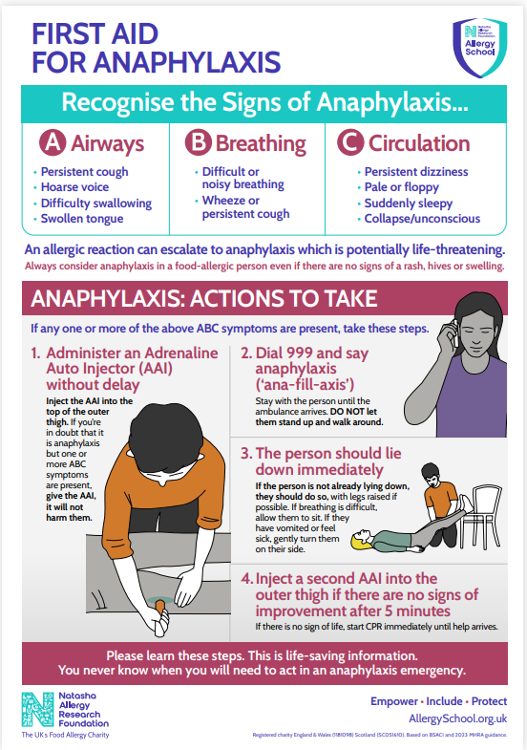
allergic reaction takes place (e.g. medication to take).

In the event that a pupil without a prescribed AAI, or who has not been medically diagnosed as being at risk of anaphylaxis, suffers an allergic reaction, a designated staff member will contact the emergency services (999) and seek advice as to whether an AAI should be administered. An AAI will not be administered in these situations without contacting the emergency services.

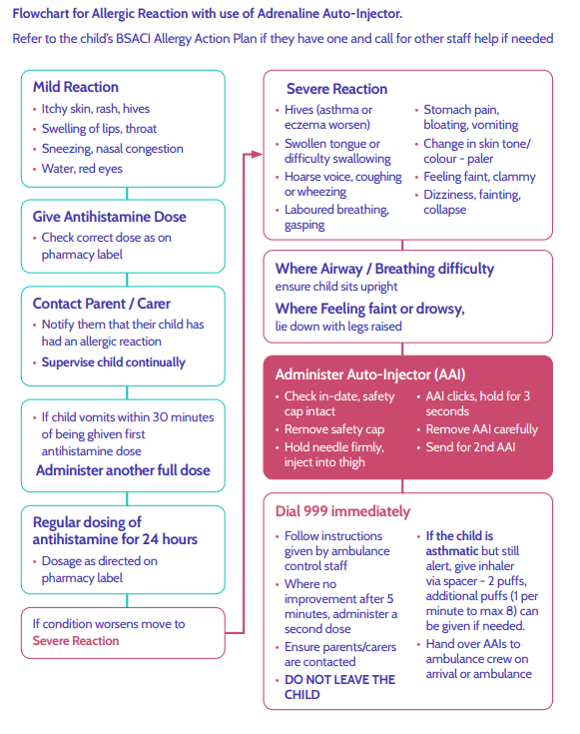
Pupil support: Staff members will ensure that the pupil is given plenty of space, moving other pupils to a different room where necessary. Staff members will remain calm, ensuring that the pupil feels comfortable and is appropriately supported.
Where there is any delay in contacting designated staff members, the nearest staff member will administer the AAI. If necessary, other staff members may assist the designated staff members with administering AAIs.
The Headteacher will ensure that any designated staff member required to administer an AAI has appropriate cover in place, e.g. if they were teaching a class at the time of the reaction.

Upon arrival of the emergency services, the following information will be provided:
- Any known allergies the pupil has
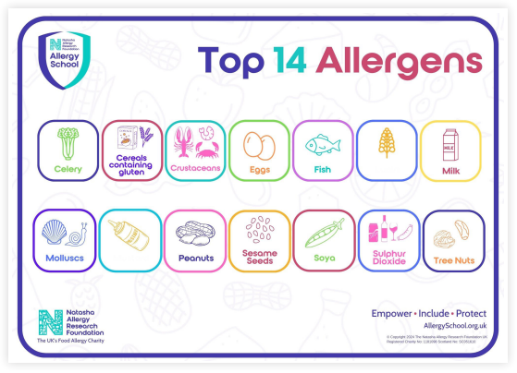
- The possible causes of the reaction, e.g. certain food

- The time the AAI was administered – including the time of the second dose, if this was administered
Any used AAIs will be given to paramedics.
A member of staff will accompany the pupil to hospital in the ambulance in the absence of their parents/carers.
Following the occurrence of an allergic reaction, the SLT, in conjunction with the First Aid
Lead, will review the adequacy of the school’s response and will consider the need for any additional support, training or other corrective action.

Appendix One: Allergy Declaration Form
(example only - may be sent out as an electronic form)
Name of pupil:
Date of birth: |  | Year group:
Name of GP:
Address of GP:

Nature of allergy:

Severity of allergy:

Symptoms of an adverse reaction:
Details of required medical attention:

Instructions for administering medication:
Control measures to avoid an adverse reaction:

Spare AAIs
I understand that the school may purchase spare AAIs to be used in the event of an emergency allergic reaction. I also understand that, in the event of my child’s prescribed AAI not working, it may be necessary for the school to administer a spare AAI, but this is only possible with medical authorisation and my written consent.
In light of the above, I provide consent for the school to administer a spare AAI to my child.
Yes | ☐ | No | ☐

Name of parent:
Relationship to child:
Contact details of parent:
Parental signature:

