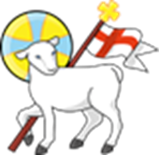
Autism

A Guide for Parents and Carers

What is Autism?

Autism, sometimes referred to as Autism Spectrum Condition (ASC), is a developmental difference that affects how a person communicates, interacts with others, and experiences the world around them. It is lifelong, but with the right understanding and support, autistic children can thrive, learn, and develop their strengths.

Key Things to Know
- Autism is a spectrum. This means every autistic child is unique. Some may need a lot of support in daily life, while others may need very little. There is no “one size fits all”.
- It is not an illness. It is a different way of thinking, learning, and processing information.
- Children with autism have strengths. Many autistic children show strong memory skills, creativity, deep focus on interests, problem-solving abilities, or a wonderful sense of humour.
How Autism May Affect a Children
- Autism commonly affects three areas:
- Communication A child may use fewer words, rely on familiar phrases, or find back-and-forth conversation difficult. Some children communicate through gestures, facial expressions, or alternative communication systems.
- Social Interaction A child may find it harder to join in play, understand social cues, or know how to start interactions. They may prefer predictable routines or familiar people.
- Sensory Processing Many autistic children experience the world more intensely. They may be very sensitive to noise, touch, or busy environments, or they may seek sensory input such as movement, pressure, or fidgeting.
- Every child’s profile is different, and strengths often sit alongside areas where support is needed.

How do you get diagnosed with Autism?
If you think your child may be autistic, the NHS advises that you first talk to someone who knows your child in a professional capacity. This could be:
- your GP
- your health visitor (for children under 5)
- your child’s school SENDCo or teacher
- another health professional involved with your child
You can ask them to refer your child for an autism assessment.

The Owl Centre
Autism assessments are now done by the Owl Centre in Hampshire. Below is the assessment process.
https://www.theowl.org/assessment-process-for-children-young-people/
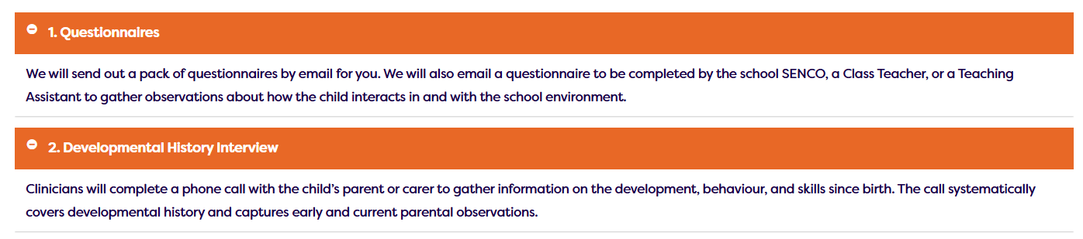
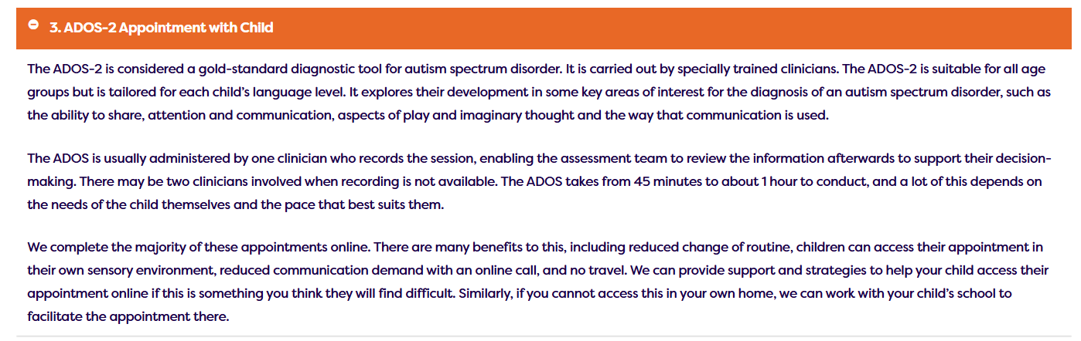
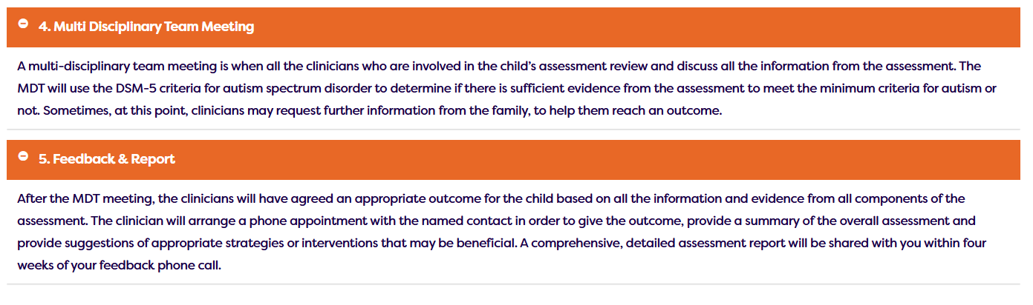

Autism and School

Ordinarily Available Provision

This is what is available in every classroom every day for all children. This enables children to learn best, additional support is put in place if these things are not working.

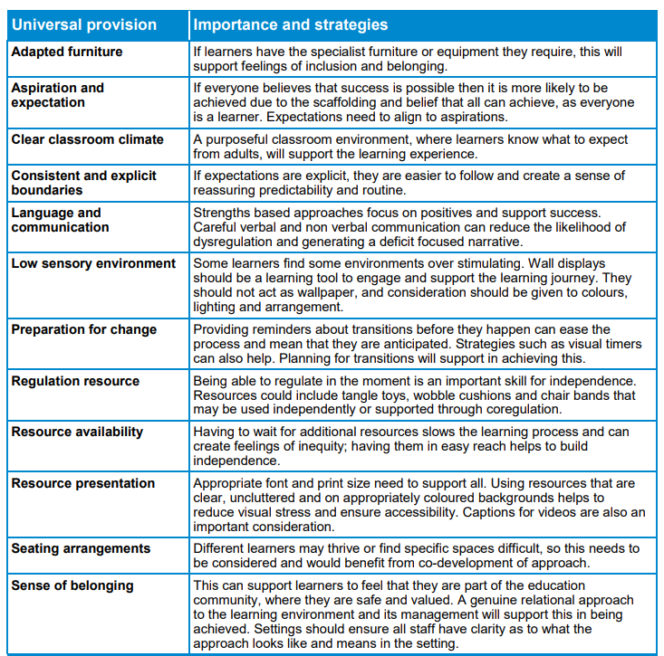

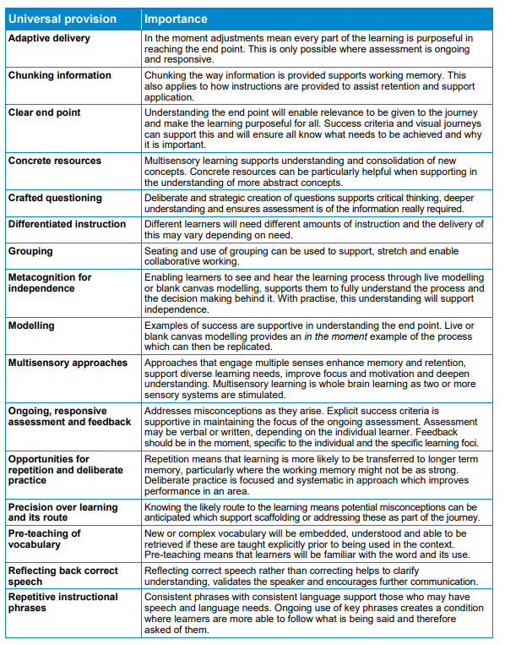
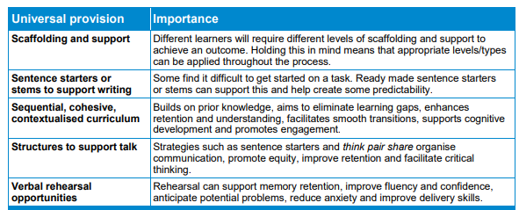
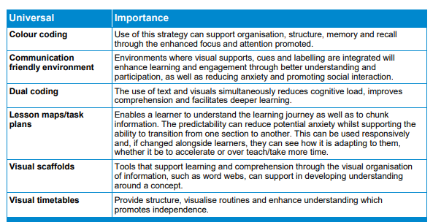

Useful Contacts

The Owl Centre
https://www.theowl.org/assessment-process-for-children-young-people/

The PDA Society
https://www.pdasociety.org.uk/what-helps-guides/childhood/
The National Autistic Society
https://www.autism.org.uk/advice-and-guidance/education/attendance-problems/parents
Ordinarily Available Provision
https://documents.hants.gov.uk/childrens-services/local-offer/oap_and_send_support_-_march_2025.pdf

