
ADHD

A Guide for Parents and Carers

What is ADHD?
Attention Deficit Hyperactivity Disorder (ADHD) is a neurodevelopmental condition that affects how a child focuses, manages impulses, and regulates their energy levels. It is not caused by poor parenting, diet, or lack of discipline. Children with ADHD often have many strengths, including creativity, problem-solving skills, curiosity, and enthusiasm.
ADHD commonly presents in three ways:
- Inattentive type – difficulties with focus, organisation, and following instructions
- Hyperactive/impulsive type – high energy, fidgeting, acting without thinking
- Combined type – a mixture of both
Every child’s profile is different.

How to Get an ADHD Assessment in Hampshire
In Hampshire, ADHD assessments for children are carried out through CAMHS (Child and Adolescent Mental Health Services) or through private providers.

1. Speak to a professional
Parents can start the process by talking to:
- Your GP
- Your child’s school SENDCo or class teacher
- A health visitor (for younger children)
You can request a referral for an ADHD assessment.

2. Referral to CAMHS
Once a referral is made, CAMHS will:
- Review the information from home and school
- Decide whether an assessment is appropriate
- Place your child on the waiting list or suggest the following parenting support:

- Togetherness - These free online courses offer advice and practical tips to boost your confidence as a parent, help you navigate family life and strengthen your relationships. They have been designed to help you understand feelings, development and behaviour, as well as focus on your own feelings as you grow as a family. https://togetherness.co.uk/

- The Centre for Emotional Health (formally Family Links) provide programmes suitable for parents of children from -9 months to 18 years, underpinned by The Nurturing Programme and developing an understanding of behaviour in the context of relationships. https://www.centreforemotionalhealth.org.uk/

- BRAAIN support parents and carers of children with Attention Deficit Hyperactivity Disorder (ADHD) and Autistic Spectrum Condition (ASC) or Special Educational Needs (SEN). More information can be found on their website www.Braain.co.uk or they can be contacted at enquiries@braain.co.uk

3. What the assessment involves
An ADHD assessment usually includes:
- A developmental history with parents
- Questionnaires for home and school
- Observations or structured tasks
- A discussion about strengths, challenges, and daily functioning

4. After the assessment
You will receive a written report explaining:
- Whether your child meets the criteria for ADHD
- Their strengths and needs
- Recommendations for home and school
Support can be put in place with or without a diagnosis.

Strategies Parents Can Use at Home
These approaches are commonly recommended for children with ADHD and can help with routines, behaviour, and emotional regulation.

1. Clear routines
- Use visual timetables or checklists
- Keep morning and bedtime routines predictable
- Give warnings before transitions (“In five minutes we will…”)

2. Break tasks into small steps
- Give one instruction at a time
- Use short, simple language
- Celebrate each step completed

3. Positive reinforcement
- Notice and praise specific behaviours (“I love how you started your homework straight away”)
- Use reward charts or tokens for motivation

4. Movement and sensory breaks
- Allow short, planned breaks between tasks
- Use movement (jumping jacks, stretching) to reset focus
- Provide sensory tools if helpful (fidget toys, chewies, weighted items)

5. Reduce distractions
- Keep workspaces clear
- Turn off background noise where possible
- Use timers to support focus

6. Emotional regulation support
- Teach simple phrases to express feelings
- Model calm breathing or grounding strategies
- Keep boundaries clear and consistent

Universal Support Available in School

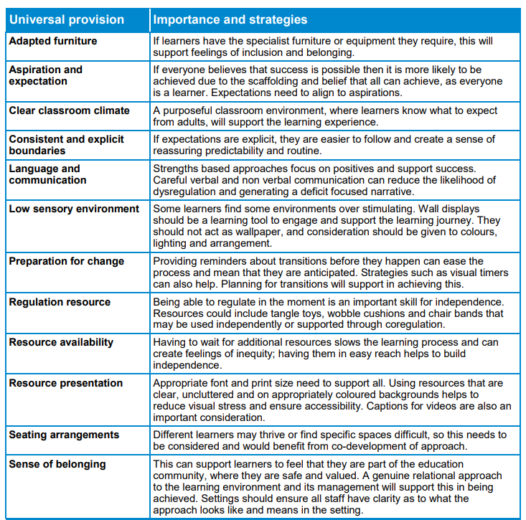
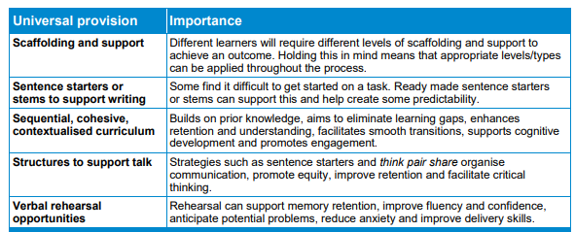
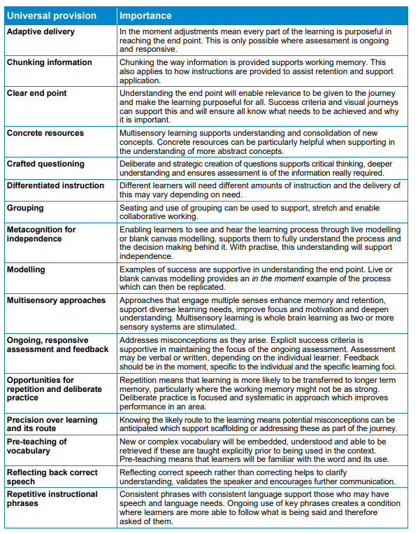
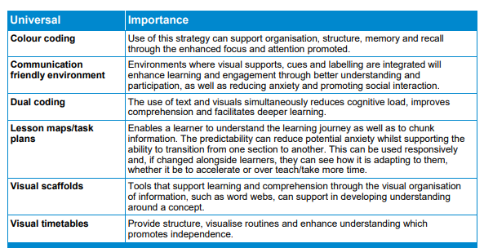

Useful Contacts
Ordinarily Available Provision
https://documents.hants.gov.uk/childrens-services/local-offer/oap_and_send_support_-_march_2025.pdf
Togetherness - These free online courses offer advice and practical tips to boost your confidence as a parent, help you navigate family life and strengthen your relationships. They have been designed to help you understand feelings, development and behaviour, as well as focus on your own feelings as you grow as a family. https://togetherness.co.uk/

The Centre for Emotional Health (formally Family Links) provide programmes suitable for parents of children from -9 months to 18 years, underpinned by The Nurturing Programme and developing an understanding of behaviour in the context of relationships. https://www.centreforemotionalhealth.org.uk/

BRAAIN support parents and carers of children with Attention Deficit Hyperactivity Disorder (ADHD) and Autistic Spectrum Condition (ASC) or Special Educational Needs (SEN). More information can be found on their website www.Braain.co.uk or they can be contacted at enquiries@braain.co.uk
https://www.connecttosupporthampshire.org.uk/family-information-and-services-hub-fish/send-local-offer/hampshire-neurodiversity-and-wellbeing-multi-disciplinary-team/
The Hampshire Neurodiversity and Wellbeing Multi-Disciplinary Team (NDW MDT) supports parents and carers of children and young people aged 9 months to 19 years. We help families understand how a child or young person’s emotions, responses, thinking patterns, and behaviours may relate to neurodivergence.
https://hampshire-nd-clinic.co.uk/
Offer assessments – including Adult ADHD assessments – to explore neurodivergence and provide tailored support for individuals and families.

