Year 2
St John the Baptist C of E Primary School
‘Creating new possibilities for our future, with compassion in our hearts and courage on our journey.’
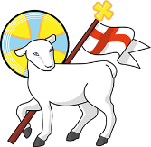
Autumn 1 - Learning Overview
Learning Journey 1:
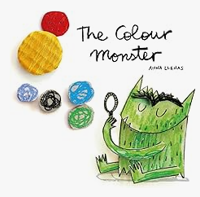
The Hook
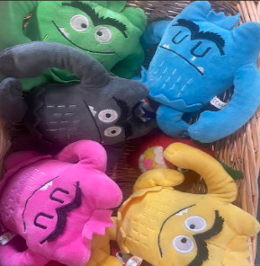
The Colour Monster

Outcome: Descriptive writing.
Learning Journey 2 :
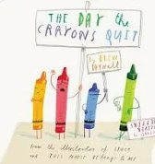
The Day the Crayons Quit
Outcome: A letter
What we will be teaching:
English:
This unit will recap Phase 5 phonics to support accurate spelling and introduce new spelling rules such as adding suffixes, while developing children’s ability to write different sentence types, including questions and exclamatory sentences. Furthermore, using coordinating conjunctions in compound sentences, and applying adjectives to create descriptive expanded noun phrases.
Maths:
In Year 2 the children will be learning to count forwards and backwards to 100, read and write numbers in numerals and words, use number lines and other representations to identify and estimate numbers, and compare and order numbers confidently. Also to count in steps of 10 from any number, forwards and backwards, identify one more/less and ten more/less. Children will be learning to recognise pounds and pence, find different coin combinations that make the same amount, and use their addition, subtraction and place‑value skills to solve practical money problems.
Geography:
Children will be learning to identify the United Kingdom, name its four countries, recognise the surrounding seas, and understand how these parts fit together on a map to build their geographical knowledge.
Science:
The children will be investigating how objects move by exploring different pushes and pulls, discovering how these forces can change the speed, direction or shape of everyday items.
ART/DT:
In Year 2 the children will be exploring how primary colours mix to make secondary colours and have enjoyed using this knowledge to design and create their own moving pictures.
RE:
This term children will be learning about Christian and Hindu creation stories, exploring how each tradition explains the beginning of the world and comparing the similarities and differences in what these stories teach.
Computing:
Children will be learning what information technology (IT) is, spotting examples in school and thinking about them in everyday places like shops, hospitals and libraries, exploring how IT helps to make tasks easier, and understanding why it is important to use technology safely and responsibly.
Science:
The children will be investigating how objects move by exploring different pushes and pulls, discovering how these forces can change the speed, direction or shape of everyday items.
ART/DT:
In Year 2 the children will be exploring how primary colours mix to make secondary colours and have enjoyed using this knowledge to design and create their own moving pictures.
RE:
This term children will be learning about Christian and Hindu creation stories, exploring how each tradition explains the beginning of the world and comparing the similarities and differences in what these stories teach.
Computing:
Children will be learning what information technology (IT) is, spotting examples in school and thinking about them in everyday places like shops, hospitals and libraries, exploring how IT helps to make tasks easier, and understanding why it is important to use technology safely and responsibly.
Thinking about primary colours and secondary colours.
Creating a moving picture
PE:
In Gymnastics, the children will describe and explain how performers can transition and link elements. Perform basic actions with control at different speeds and levels. Develop flexibility in a range of shapes and balances. In outdoor PE, the children will be focusing on attack, defence and shooting skills. This includes sending a ball using feet and can receive a ball using feet. Refine ways to control bodies and a range of equipment. Recall and link combinations of skills, e.g., dribbling and passing.
Music:
In this unit of music the children will be thinking about what timbre means and identifying percussion instruments by their sound and improvising using Question and Answer phrases on untuned instruments.

Messages to parents:
Thank you for a warm welcome back to the new academic year. The Year 2 team is excited to work with your children, and with you, to support their learning and ensure the very best outcomes throughout the year.

Please keep reading with your child at home. Our P.E days will be Monday and Thursday.
Our library day is a Monday.

Please contact us if you need any support with your child, as working in partnership is so important to us.
The Year 2 Team
year_2@stjohnthebaptistprimary.co.uk

