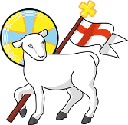
Year 6
St John the Baptist C of E Primary School
‘Creating new possibilities for our future, with compassion in our hearts and courage on our journey.’

Autumn 1 - Learning Overview
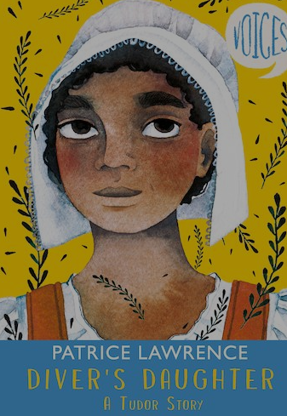

The Hook
The Diver’s Daughter by Patrice Lawrence
A modern mystery set in Tudor times
Can modern day forensics reveal the rogues in this story?
A Science investigation using disciplinary skills will reveal the culprit!

What we will be teaching:
English: We will be writing our own narratives, using figurative language, selecting adjectives with precision and using relative clauses to add detail. We will focus on selecting sentence structures carefully to create impact. We will also explore the role of an apothecary and write a diary entry. Throughout this unit, we will develop our authorial voice and build confidence in our creative writing skills.
Maths:
In Maths we will focus on place value and where decimals fit on the place value grid. We will explore negative numbers and rounding as well as division and multiplication formal methods
History/Geography:
In History we will be exploring the Tudor monarchy and their role in British History and world events. We will also be learning about Tudor politics and lifestyles of different classes. In Geography we will make links with our local area and explore Portsmouth during Tudor times.
Science:
In science we will be recapping and deepening our understanding of the circulatory system
ART/DT:
In art we will focus on one point perspective and sketching techniques. Cynthia B Crier, LS Lowry will be our focus artists
DT : We will create moving pictures using pivots and levers.
RE:
Creation or Science: conflicting or complementary?
Computing:
We will be looking at communication and the internet.
PE:
Tag Rugby and Gymnastic sequences
French:
We will be learning to appreciate french culture and learn facts about France
Music: Composing, playing pitch, dynamics, structure

Messages to parents:
Remember to check the St John’s jottings weekly for dates of upcoming events in school. This is emailed each Friday and is designed to keep our community up-to-date on important events in school.
Keep in Touch : year_6@stjohnthebaptistprimary.co.uk

