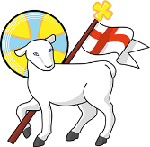
Year 5
St John the Baptist C of E Primary School
‘Creating new possibilities for our future, with compassion in our hearts and courage on our journey.’

Autumn 1 - Learning Overview
The Hook
- - The Willow Pattern Story by Allan Drummond

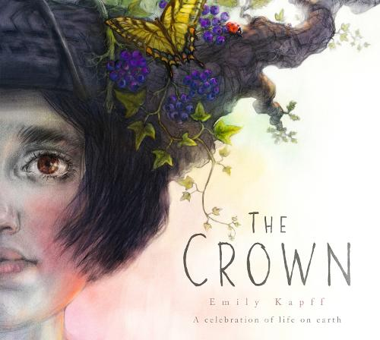

Through The Crown, children will explore the journey of a valuable natural resource and consider where the materials we use come from. The book will encourage pupils to think about the Earth's resources, how they are used and the importance of using them responsibly. As a lesson hook, children could be presented with a mysterious crown and challenged to investigate: What is it made from, where did these materials come from and what journey did they take to reach us?

2 - A range of non-fiction texts including Shang Dynasty China by Tracey Kelly

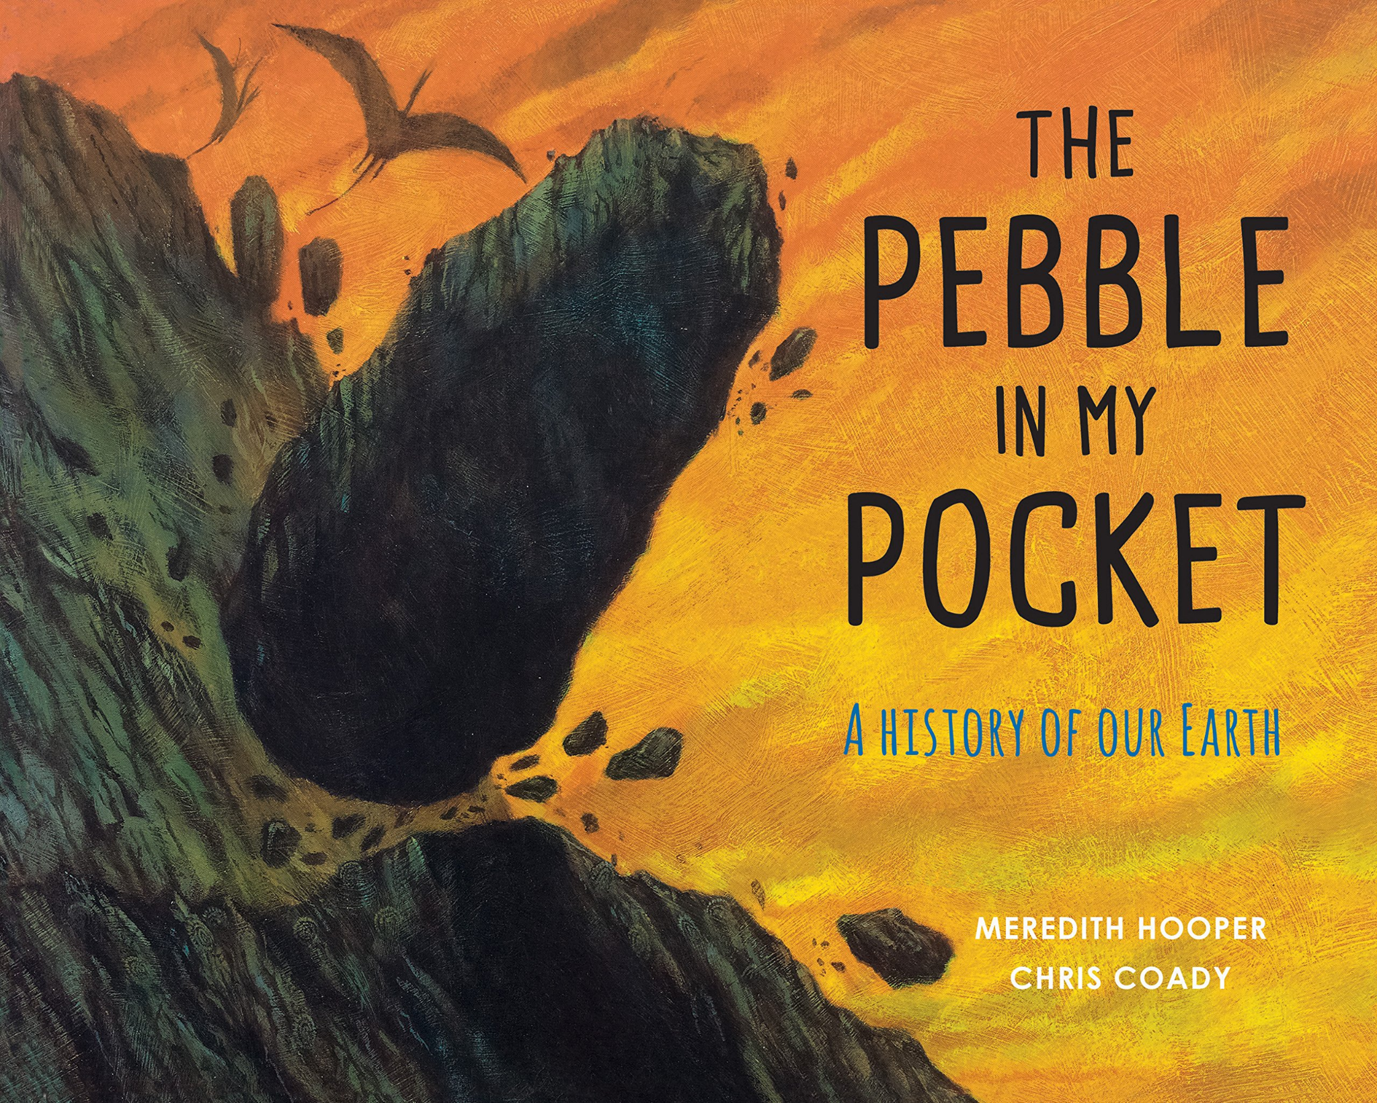
In The Pebble in My Pocket, children follow the incredible journey of a single pebble across millions of years. The book will support our learning about geological time, helping pupils to understand how the Earth has changed and how rocks and landscapes are formed. As a lesson hook, each child could be given a pebble and asked: If this pebble could tell its story, where has it been and what changes to the Earth might it have witnessed?

What we will be teaching:

English:
This half term, children will develop their skills in writing for different audiences and purposes. They will explore how to select appropriate language and grammatical features to create a particular effect, including the use of expanded noun phrases and carefully chosen vocabulary. Children will also focus on organising their writing effectively through the use of clear paragraphs, headings, subheadings and bullet points, while developing cohesion within and across paragraphs. They will be encouraged to edit and improve their work, considering how their language choices can engage and influence the reader.
Maths:
During this term we work through units on: number and place value, addition and subtraction (including length), multiplication and division (with areas and arrays) and fractions.
History/Geography:
This term there is a focus on Geography. Our topic is ‘Our Resourceful World’ which begins with exploring different countries in the atlas. We will then explore the resources of clean water, food and energy. Children will develop their understanding of the necessity for these resources and where in the world they come from, before evaluating if every country is equal.
Science:
Our unit is fossils, geographic time and classifications. The children have already been drawing upon their learning from Year 4 and have made exciting links to their RE topic this half term.
ART/DT:
This term the focus is on Art, specifically the skill of drawing. The children will be exploring a variety of mark making techniques to eventually create a detailed drawing inspired by their lizard research.
RE:
Creation - Creation or Science: conflicting or complementary? We will explore this question through developing children's understanding of the story Genesis 1. The children will then learn about cosmology and alternative beliefs, before answering our question at the end of the unit.
Computing:
Computing systems and networks. The class were instantly engaged with this unit when asked to apply their understanding of the systems on a bicycle.
PE:
Indoor PE is Gymnastics this half term. The children will be learning different positions, creating sequences in groups, as well as how to use a variety of apparatus safely. Outdoor PE is football. Each week will focus on a different skill like dribbling or passing before we begin to play matches as a class.
French:
- La Rentrée (Back to School) - Focus on a French Primary School
- French Culture - What defines culture and specifically French culture
- Fascinating Facts about France - What do we know already? What can we find out?
- French Spoken around the world - Only in France or other countries too?

Messages to parents:
Remember to check the St John’s jottings weekly for dates of upcoming events in school. This is emailed each Friday and is designed to keep our community up-to-date on important events in school.

Keep in Touch : year_5@stjohnthebaptistprimary.co.uk

