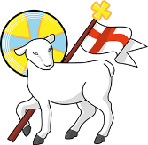
Year 4
St John the Baptist C of E Primary School
‘Creating new possibilities for our future, with compassion in our hearts and courage on our journey.’

Autumn 1 - Learning Overview
The Hook
The children used their inference skills and studied the Bayeux Tapestry which retold the story of the Battle of Hastings.
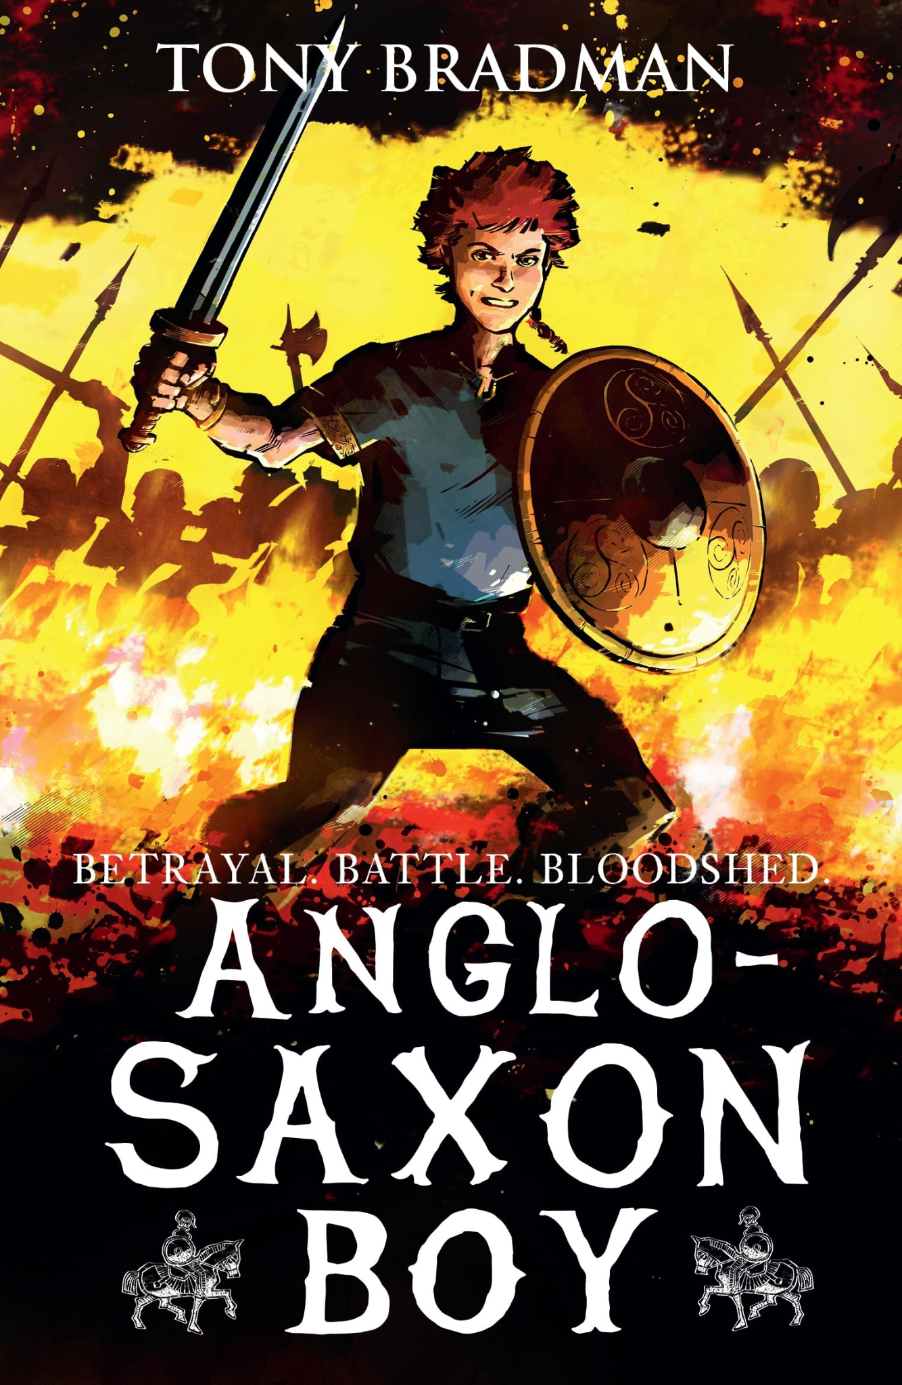
Learning journey 1: Anglo-Saxon Boy

Learning journey 2: How to be an Anglo-Saxon
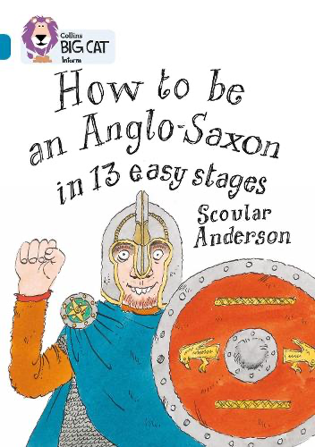
What we will be teaching:
English:
Learning Journey 1: The children will be writing a narrative to start with in Year 4. They will be focusing on using a variety of different word choices to help build tension and effect for the reader, whilst also making sure they are using the correct technical vocabulary linked to the topic. They will have an opportunity to recap using co-ordinating conjunctions, direct speech and adverbs to make the writing more exciting and engaging for the reader.
Learning Journey 2: Otter Class will be continuing focusing on Anglo-Saxons and will create their own non-chronological report on life as an Anglo-Saxon. They will focus on using subordinating conjunctions, embedded clauses and a variety of sentence starters to sound informative to the reader. They will also look into paragraphing and structure to ensure they have a clear understanding of that particular writing style.
Maths:
Otter class will be focusing on recapping their 2s, 3s, 4s, 5s, 8s and 10 times tables whilst also being introduced to 6s and 9s this half term. They will also be having weekly practice time on TTrockstars to support them with their Multiplication Times Table Check in June. The children will also be recapping place value and move onto understanding 1000 place value and tenths and hundredths. The children will build on their knowledge of rounding to the nearest 10 and 100 and apply to rounding to the nearest 1000. Finally, Otter Class will look into measurement and converting money and length by either dividing or multiplying by 10 or 100.
History/Geography:
Anglo-Saxons
Year 4 will start the year by learning about the Anglo-Saxons. The children will learning and understand where they originated from and why they invaded Britain, some of the key kingdoms and people, their culture, religion and way of life.
Science:
Mixtures and Solutions
The children will be looking into the effect different mixtures and solutions have on each other. The will look and compare the different states of matter, how to change the states of matter by using heating and cooling strategies and looking at other methods on how to separate different materials.
ART/DT:
Textiles
We will be creating a final piece of making an Anglo-Saxon ragdoll. The children will be looking into practising different types of stitches, carefully making detailed plans and using templates to cut on different materials to help create their final product.
RE:
Creation: What does the creation story mean to Christians?
Otters will be looking and recapping the story of Creation and looking deeper into the story of Adam and Eve and ‘The Fall’ where Eve ate from the apple tree. We will be questioning how Christians believe that God guides his people and how there are different rules to follow and what the consequences could be.
Computing:
Network and the internet
Children will understand how and what networking is. They will also explore how different places can receive the internet and how it is linked to computers in that particular area. The children will also look at how information is shared on the world wide web and how to be safe when searching online.
PE:
Tag rugby
The children will be building on their team skills by thinking about their speed, agility, ball confidence and passing.
Gymnastics
Otter class will be focusing on movement and positioning in their gymnastics this term whilst using the different equipment to add to their creativity.
French:
Cultural understanding, greetings and responses
The children will recap and build on their prior knowledge on greetings whilst also going in depth of explaining their emotions in a discussion. They will also learn more information about France and their culture.
P.D.L:
Me and my relationships
Year 4 will focus on the first half term of looking into learning about recognising their own emotions and feelings whilst also finding strategies to resolve conflicts. They will also understand the importance of communicating and listening.
Messages to parents:
Welcome to Year 4 and I hope everyone had a wonderful, enjoyable and safe break. I am very excited to start this academic year and I am looking forward to getting to know the children and be a part of their learning journey here at St Johns.
Year 4 Statutory Timestable Test (MTC)
This year, the children will be expected to take part in a government check of their times tables. This is called the Multiplication Times Table Check (MTC). The test usually takes place during the first few weeks of June, but official dates will be confirmed at a later time. The test consists of 25 questions where the children will have 6 seconds to type in the answer and it is based on any of the times tables up to 12x12. These questions will be random and we cannot predict which questions will be asked. If you can spend some time this year doing some extra practice with the children’s times tables to help continue to build their confidence, I would really appreciate the support to help the children to succeed. A parent information afternoon will be provided later on in the academic year to give more information about the test and a chance for you to ask any questions. In the meantime, you can find further information in the attached booklet.
P.E and library days
Library days: Thursday
P.E days: Monday and Wednesday

Home learning:
Home learning will be given as an A4 sheet every Wednesday which will be due back the following Wednesday. More information to follow shortly.

As always, please contact us if you need any support with your child, as working in partnership is so important to us.

The Year 4 Team

