
St John the Baptist Church of England
Primary School

Attendance Policy
2026 - 2027

Review Frequency:  Last Reviewed:  Next Review Due: |  | Annually  September 2026  September 2027
Approved by:
The Governing Body & Headteacher
Date Approved: September 2026

‘Through our core Christian values, we aim to create new possibilities for our future, with compassion in our hearts and courage on our journey.’

Whole School Attendance Policy

Policy Consultation & Review

This policy is available on our school website and is available on request from the school office. We also inform parents about this policy when their children join our school and regularly thereafter through our school newsletter and other relevant opportunities.

We recognise the expertise our staff build by managing school attendance daily and we therefore invite staff to contribute to and shape this policy and associated attendance and safeguarding arrangements.

This policy will be reviewed in full by the Governing Body on at least an annual basis.

- Introduction/Aim

At St John the Baptist Primary C of E School we believe that regular school attendance is essential if children are to achieve their full potential. We value the attendance of all pupils. Missing out on lessons leaves children vulnerable to falling behind and can put them at risk of wider harm. There is a wide range of evidence as to the health and wellbeing benefits of school-age education. Research commissioned by the Department for Education shows missing school for even a day can mean a child is less likely to achieve good grades, which can have a damaging effect on their life chances. As set out in this policy, we will work with families to identify the reasons for poor attendance and try to resolve any difficulties at the earliest opportunity.
Our attendance policy aims to give clear guidance to staff, parents, pupils, and governors/trustees to:
- Promote good attendance, enabling pupil’s achievement by establishing the highest possible levels of attendance and punctuality.
- Recognise the key role of all staff in promoting good attendance.
- Provide a clear framework for monitoring and responding to pupil absences, acting early to address patterns of absence.
- Building strong relationships with families to ensure pupils have the support in place to attend school.
- Promote positive support systems and advocate multi-agency approaches to improve attendance.
- Make parents aware of their legal responsibilities and ensure their children have access to the education to which they are entitled.
We recognise that attendance is a matter for the whole school community. Our Attendance Policy should not be viewed in isolation; it is a strand that runs through all aspects of school improvement, supported by our policies on safeguarding, prevention of bullying, behaviour, and inclusive learning. This policy also considers the Human Rights Act 1998, the Equality Act 2010, UN Convention on the Rights of the Child, and other relevant legislation.

- Legal Framework

This policy meets the requirements of the Working together to improve school attendance from the Department for Education (DfE), and refers to the DfE’s statutory guidance on school attendance parental responsibility measures.
Section 7 of the 1996 Education Act states that parents must ensure that children of compulsory school age receive efficient full-time education suitable to their age, ability, and aptitude to any special educational needs they may have, either by regular attendance at school or otherwise. A child is of compulsory school age at the beginning of the term following their 5th birthday. A child ceases to be of compulsory school age on the last Friday in June of the school year in which they reach the age of 16.
The government expects all schools and local authorities to:
- Promote good attendance and reduce absence, including persistent and severe absence.
- Ensure every pupil has access to full-time education to which they are entitled.
- Act early to address patterns of absence.
Parents are expected to perform their legal duty by ensuring their children of compulsory school age who are registered at school attend regularly.

In accordance with the Education Act 1996, we will work with parents and carers and the Local Authority to ensure that parents and carers are supported to secure education for children of compulsory school age. Where required, we will formalise support and where necessary, work with the LA to use legal measures.
A “Parent” is defined as:
- Any natural parent, whether married or not.
- Any parent who, although not a natural parent, has parental responsibility as defined in the Children Act (1989) for a child or young person.
- Any person who, although not a natural parent, has care of a child or young person.

- Roles and Responsibilities

At St John the Baptist Primary C of E School, we believe that improving school attendance is everyone’s business. It is a shared responsibility by governors, all school staff, parents, pupils, the wider school community and multi-agency partners. We aim to always work in partnership with our parents.

Role | Name | Contact details
Senior Attendance Lead/Champion | Mrs R. Livings | Via the school offices  or  admin@stjohnthebaptistprimaryschool.co.uk
Named Governor for Attendance | Full Governing Body | Via  clerk@Stjohnthebaptistprimary.co.uk

The Governors of St John the Baptist Primary C of E School recognise the importance of school attendance and promotes it through the school’s ethos and across its policies. They may take an active role in attendance improvement by:

- Setting high expectations of all leaders, staff, pupils, and parents so that children attend school every day and are safeguarded.
- Identifying a member of the governing body to lead on attendance matters and ensuring that there is a named senior manager to lead on attendance.
- Prioritising attendance in strategies, such as raising attainment, behaviour and combatting bullying, special educational needs and disabilities, wellbeing, and safeguarding.
- Ensuring school leaders fulfil expectations and statutory duties by rigorously evaluating the effectiveness of the school’s attendance procedures so that consistent attendance support is provided for all pupils.
- Ensuring the schools’ attendance management processes are delivered effectively, and that consistent attendance support is provided for pupils who require it most by prioritising the staff and resources needed. This includes ensuring schools engage and work effectively with the local authority School Attendance Support Team and wider local partners and services.
- Regularly reviewing attendance data, discussing, challenging trends, and helping school leaders focus improvement efforts on the individual pupils or cohorts who need it most.
- Ensuring high aspirations are maintained for all pupils and processes for support are adapted to the individual needs of pupils including those with long term illnesses, special educational needs and disabilities, pupils with a social worker, those pupils under the Virtual School and pupils from cohorts with historically lower attendance such as those eligible for free school meals.
- Ensuring all school staff receive adequate training on attendance and that relevant staff have access to opportunities to share and learn from good practice in other schools.
- Ensuring that attendance data is shared with the Local Authority or Department for Education in line with statutory reporting deadlines.
- Reviewing the school’s Attendance Policy on at least an annual basis, ensuring that the required resources are available to fully implement the policy, which is published and publicised regularly so that it is easily accessible to pupils, parents and staff.

The Senior Leadership Team at St John the Baptist Primary C of E School will:

- Actively promote the importance and value of good attendance to pupils and their parents.
- Form and maintain positive relationships with pupils and parents.
- Ensure that there is a whole school approach which reinforces good school attendance, with good teaching and learning experiences, with a whole school culture that encourage all pupils to attend and to achieve.
- Make sure all teaching and non-teaching staff know the importance of good attendance, are consistent in their communication with pupils and parents, and receive the training and professional development they need.
- Have a clear school attendance policy which all staff, pupils and parents understand. Monitor the implementation and effectiveness of the Attendance Policy and ensure that the policy is reviewed annually.
- Ensure the school have accurate, complete admission and attendance registers and have effective day to day processes in place to follow-up absence.
- Regularly monitor and analyse attendance and absence data to identify pupils or cohorts that require support with their attendance and put effective strategies in place.
- Share information and work collaboratively with other schools in the area, local authorities, and other partners where a pupil’s absence is at risk of becoming persistent or severe.
- Ensure that there is a named Senior Attendance Champion to lead on attendance and allocate sufficient time and resource.
- Attend the termly school attendance supporting meetings with the local authority (or equivalent), focusing on those pupils with severe absence, making sure a regularly reviewed plan is in place.

All staff at St John the Baptist Primary C of E School will:

- Actively promote the importance and value of good attendance to pupils and their parents.
- Form positive relationships with pupils and parents.
- Contribute to a whole school approach which reinforces good school attendance; with good teaching and learning experiences that encourage all pupils to attend and to achieve.
- Know the importance of good attendance, are consistent in their communication with pupils and parents, and receive the training and professional development they need.

The member of staff responsible for attendance will work to further develop relationships with families to bring about improved attendance. This may involve seeking multi-agency support.

St John the Baptist Primary C of E School requests that parents:
- Take a positive interest in their child’s work and educational progress.
- Ensure their child has regular attendance at school.
- Instil the value of education and regular school attendance within the home environment.
- Contact the relevant school if their child is absent to let them know the reason why and the expected date of return.
- Avoid unnecessary absences; for example, by making medical and dental appointments for outside of school hours.
- Provide written proof in advance of any medical or dental appointments that must be taken during school hours.
- Ask the school for help if their child is experiencing difficulties with any aspect of their schoolwork or home and family life.
- Inform the school of any change in circumstances that may impact on their child’s attendance.
- Support the school by becoming involved in their child’s education, forming a positive relationship with school, and acknowledging the importance of children receiving the same messages from both school and home.
- Maintain effective routines at home to support good attendance and punctuality.
- Attend all meetings requested to discuss attendance issues.

Further information can be found at: Attendance guidance for parents | Hampshire County Council (hants.gov.uk)

Pupils will:
- Be aware of the school’s attendance policy and when and where they are required to attend. This will be communicated to them by school staff, parents and through the school timetable.
- Speak to their class teacher or another member of staff if they are experiencing difficulties at school or at home which may impact on their attendance.
- Attend all lessons ready to learn, with the appropriate learning tools requested and on time for the class.
- Follow the school procedure if they arrive late. This will help the school to monitor attendance and keep accurate records for the child’s individual attendance. This is also vital for health and safety in the event of a school evacuation.

- Categorising Absence and Attendance

When marking our registers, we will apply the national codes as outlined and regulated by the Department for Education guidance to accurately record and report attendance.

4.1 Leave of Absence

Since September 2013, changes to Government regulations and guidance mean that Headteachers can no longer authorise leave of absence unless there are exceptional circumstances. Generally, the DfE does not consider a need or desire for a holiday or other absence for the purpose of leisure and recreation to be an exceptional circumstance. Leave of absence should not be granted for a pupil to take part in protest activity during school hours. All absences associated with a holiday or other absence for the purpose of leisure and recreation during term time will be marked as unauthorised within the register. Any parents known to have removed their child from school for the sole purpose of a holiday or other absence for the purpose of leisure and recreation may be referred to the Local Authority and be issued with a penalty notice fine or referred to the Local Authority to consider prosecution.
We believe that children need to be in school for all sessions so that they can make the most progress possible. However, we do understand that there are times where a parent may legitimately request leave of absence for a child due to ‘exceptional circumstances'. At St John the Baptist Primary C of E School leave of absence is only granted at the discretion of the Headteacher and shall not be granted unless there are ‘exceptional circumstances’. St John the Baptist Primary C of E School will respond to all applications for leave of absence, submitted on the required form, in writing.
Parents wishing to apply for leave of absence during term time must apply in writing to the Headteacher at least a month before the planned leave (see Appendix 2). If a written request for leave of absence is not completed and the leave is taken without a request being submitted, the leave will not be considered by the Headteacher, and it will be marked as unauthorised. St John the Baptist Primary C of E School will treat each application individually and discuss with you the circumstances of the application before a decision is made. Retrospective requests will not be considered and therefore will result in the absence being categorised as unauthorised.
A penalty notice request or a referral for prosecution may be submitted to the Local Authority should: -
- The parent fails to submit a leave of absence request in advance of taking the leave.
- An application for a leave of absence is not agreed by the Headteacher but is still taken.
- A longer period is taken more than the agreed number of days.

When absence is granted by the Headteacher, the parents will need to agree a date of return. If a pupil fails to return on the expected date and contact is not received from, or made with the parents, school will seek advice from the Local Authority. This could result in possible children missing from education procedures being instigated.

The 1996 Education Act also sets out the circumstances in which a pupil has not failed to attend school regularly and therefore the parent has not committed an offence.
4.2, 4.3, 4.4 are examples of these.

4.2 Medical Appointments and absence due to illness

Parents should try to make appointments outside of school hours wherever possible. Where appointments during school time are unavoidable, we ask that parent notifies the school in advance of the appointment wherever possible. The pupil should only be out of school for the minimum amount of time necessary for the appointment. In most circumstances, a child should not miss a whole day at school for an appointment. If a pupil must attend a medical appointment during the school day, they provide written evidence of the appointment in advance, along with evidence regarding why this cannot be out of school hours, and sign the child in and out of school in person. No pupil will be allowed to leave the school site without parental confirmation or supervision.

In line with Department for Education guidance, if we do have a genuine concern about the authenticity of the illness, we may ask the parent to provide medical evidence, such as a prescription, appointment card, or other appropriate form of evidence. If the school is not satisfied about the authenticity of the illness, the absence will be recorded as unauthorised.

Where a child has an emerging a pattern of non-attendance, we will discuss the reasons for absence with the child’s parent. We will invite parents to attend a support meeting as an appropriate early intervention strategy. As part of this support, we may seek consent from parents and the pupil as appropriate to make a referral to the School Nursing Team and/or to liaise with the child’s healthcare professional.

Where a pupil has a verified and chronic health condition, we will aim to work with parents to ensure children have access to education and provide appropriate support in line with Supporting pupils with medical conditions at school and Hampshire policies regarding supporting children with health issues, Behaviour and attendance resources for schools | Hampshire County Council (hants.gov.uk). We will also consider whether an Individual Healthcare Plan is required.

4.3 Pupil Absence for the purposes of Religious Observance

St John the Baptist Primary C of E School acknowledges the multi-faith nature of British society and recognises that, on some occasions, religious festivals may fall outside school holiday periods or weekends and is recognised as such by a relevant religious authority. Where this occurs, the school will consider either authorising the pupil absence or making special leave for religious observance. Parents are requested to give advance notice to the school.
Working together to improve school attendance - GOV.UK (www.gov.uk).

4.4 Parent travelling for occupational purposes

The pupil is a mobile child and their parent(s) is travelling in the course of their trade or business and the pupil is travelling with them. A mobile child is a child of compulsory school age who has no fixed abode and whose parent(s) is engaged in a trade or business of such a nature as to require them to travel from place to place.

To ensure we can effectively support all our pupils, we ask that parents:
- Advise the school of their forthcoming travelling patterns as soon as these are known and before they happen; and
- Inform the school regarding proposed return dates.

4.5 Unauthorised Absence

Absence will not be authorised unless parents have provided a satisfactory explanation and it is accepted as such by the school. The decision to authorise absences is at the discretion of the Headteacher. Examples of unsatisfactory explanations include but are not limited to:
- A pupil’s/family member’s birthday
- Shopping for uniforms
- Arrangements or appointments for cutting the pupil’s hair
- Closure of a sibling’s school for INSET (or other) purposes
- An unwillingness to attend school, or inability to attend owing to inadequate personal/family organisation
- A refusal to attend school on health grounds but where the pupil is considered well enough to attend
- Absences taken without the authorisation of the school

- Our Procedures

- Weekly meeting between Headteacher (HT) and supporting colleagues e.g. SENco to track attendance of all pupils using Arbor data. Looking at attendance rates, punctuality and patterns of absence.

Internal process for below 97% attendance:
Step 1: 100%-95% attendance – Expected level of attendance. Report this to families at Parents’ Evenings and with annual report.
Step 2: Informal (verbal) contact for children dropping below 97%. Monitored by HT.
Step 3: 90%-95% attendance - cause for concern - HT (via letter) to offer support, informally in first instance. If improvement seen, no further action. If no improvement seen, action plan required to improve.
Step 4: below 90%, or failure to improve after stage 3 - this is classed as persistent absence. Formal letter sent (notice to improve) and meeting with HT. Consideration given to referral to Children’s Services and / or Legal Intervention Team.

  - Register Keeping and Recording

The Education (Pupil Registration) (England) Regulations 2006, as amended by 2016 regulations, require schools to take an attendance register twice a day, once at the start of the morning session and then again during the afternoon session.

For the purpose of this policy, the school defines:
“Absence” as:
- Arrival at school after the register has closed
- Not attending school for any reason
“Regular” attendance as:
- Attendance at every session the school is open to pupils unless their absence has been authorised

Pupils must arrive in school by 0850 on each school day.
The register for the first session will be taken at 0850 and will be kept open until 0900. The register for the afternoon session will be taken as soon as pupils return to class following lunch break.
Registers are legal records and all schools must preserve every entry in the attendance or admission register for 6 years from the date the data was entered. As the attendance register is a record of the pupils present at the time it was taken, the register should only routinely be amended where the reason for absence cannot be established at the time it is taken and it is subsequently necessary to correct the entry. Where amendments are made, all schools must ensure the register shows the original entry, the amended entry, the reason for the amendment, the date on which the amendment was made, and the name of the person who made the amendment
On each occasion the register is taken the appropriate national attendance and absence code must be entered for every pupil (of both compulsory and non-compulsory school age) whose name is listed in the admission register at the time. The codes enable schools to record and monitor attendance and absence in a consistent way and are used to collect statistics. The data helps schools, local authorities, and the government gain a greater understanding of the delivery of education and the level of, and reason for, absence.
5.2 Reporting to parents

The school will regularly inform parents about their child’s attendance and absence levels. This will be at Parents’ Evenings and in annual pupil reports.

5.3 Late Arrival at School

At St John the Baptist Primary C of E School all pupils are expected to arrive on time for every day of the school year. The school day begins at 0850 (rolling registration from 0840). We advise all parents to ensure their child is on site prior to this. The school register will be taken at 0850. All pupils arriving after this time are required to report to the main office with their parents, who will be expected to sign the late book and provide a reason for their absence. If their arrival is before 0900 it will be recorded as late - L code (late before the close of register).

The school register will officially close at 0900. All pupils arriving on or after this time will be marked as having an unauthorised absence for the morning session - U code (late after the close of register). This is categorised as an unauthorised absence for the session. Parents will be contacted to discuss any patterns of late arrival. Repeated arrival after the close of registration will result in appropriate interventions being instigated and may also result in a penalty notice being issued or prosecution.

Registers are legal records and all schools must preserve every entry in the attendance or admission register for 6 years from the date the data was entered. As the attendance register is a record of the pupils present at the time it was taken, the register should only routinely be amended where the reason for absence cannot be established at the time it is taken and it is subsequently necessary to correct the entry. Where amendments are made, all schools must ensure the register shows the original entry, the amended entry, the reason for the amendment, the date on which the amendment was made, and the name of the person who made the amendment.

  - Expected absence procedure for parents

A parent has a legal responsibility to ensure that their child attends school regularly. If a child is unavoidably absent from school parents are expected to contact school by telephone call on the morning of the first day of absence and on each subsequent day, identifying the reason for absence and the expected date of return. If no contact is received, then absence protocols will be instigated.
If a child is absent, the following actions will be initiated by the school:
- The first day calling procedures will be activated for all pupils who are not in school after close of register and where no reason for absence is known.
- If there is still no contact made from the pupil’s parents/carers, a further telephone call home will be made again that morning. If no response can be gained, the child’s named emergency contact will be telephoned.
- If school cannot contact a parent a home visit may be carried out.
- School will telephone home if a pupil leaves the school without permission.

In certain circumstances the school may also:
- Visit the home of the pupil.
- Write to the parents of a pupil to highlight attendance or punctuality issues.
- Invite parents to discuss how school can support the family to make improvement.
- Refer to Inclusion Support Service for support, guidance, and advice.
- Refer to the Local Authority for joint enquiries to be made to establish the whereabouts of the child through Inclusion Support Service (ISS) | Hampshire County Council (hants.gov.uk) and Behaviour and attendance resources for schools | Hampshire County Council (hants.gov.uk)
- Refer to the Local Authority to consider issuing a penalty notice or to consider prosecution when all other interventions have failed, or an unauthorised leave of absence has been taken.
- Refer the matter to an appropriate external agency for multi-agency support, such as implementing a Family Support Plan or consulting with the Children’s Social Care or the police, where there are safeguarding concerns.

5.5 Attendance Rewards & Interventions

St John the Baptist Primary C of E School expects attendance for all pupils to be at least 95% (aiming for 97%). However, we understand that medical needs and some exceptional circumstances may impact on this for a small number of pupils.

Our school does not offer individual rewards for good attendance as we believe, at primary school age, pupils are not able to take responsibility for their own attendance – this is the role of the parents/carers. We are also mindful that children with significant health needs or particular circumstances should not be penalised for genuine reasons for absence.

5.6 Monitor and Analyse attendance

St John the Baptist Primary C of E School will:
- Monitor and analyse weekly attendance patterns and trends and deliver intervention and support in a targeted way to pupils and families. This should go beyond headline attendance percentages and should look at individual pupils, cohorts and year groups (including their punctuality) across the school.
- Use this analysis to provide regular attendance reports to class teachers to facilitate discussions with pupils and to leaders (including any special educational needs coordinators, designated safeguarding leads and pupil premium leads).
- Undertake frequent individual level analysis to identify the pupils who need support and focus staff efforts on developing targeted actions for those cases.
- Conduct thorough analysis of half-termly, termly, and full year data to identify patterns and trends. This should include analysis of pupils and cohorts and identifying patterns in uses of certain codes, days of poor attendance and where appropriate, subjects which have low lesson attendance.
- Benchmark attendance data (at whole school, year group and cohort level) against local, regional, and national levels to identify areas of focus for improvement.
- Devise specific strategies to address areas of poor attendance identified through data.
- Monitor in the data the impact of school wide attendance efforts, including any specific strategies implemented. The findings should then be used to evaluate approaches or inform future strategies.
- Provide data and reports to support the work of the board or governing body and local authority when appropriate.

At St John the Baptist Primary C of E School we will investigate any pupils who are on track to be persistently absent (PA) and will not wait until attendance is below 90%.
“Persistent absenteeism” (PA) as:
- Missing 10% or more of schooling across the year for any reason

“Severe absence” (SA) as:
- Missing 50% or more of schooling across the year for any reason
St John the Baptist Primary C of E School recognises severe absence as attendance below 50%, in line with DfE definitions. Pupils with severe absence are at significant risk of harm, educational disadvantage and social isolation.
We will:
- Identify pupils with severe absence through weekly monitoring.
- Prioritise these pupils for immediate intervention and multi-agency support.
- Ensure a regularly reviewed plan is in place, shared with the Local Authority at termly attendance meetings.
- Work with families to remove barriers and ensure access to full-time education.

5.7 Support Systems

At St John the Baptist Primary C of E School we recognise that poor attendance can be an indication of difficulties in a family’s life. This may be related to problems at home and or in school. Parents are encouraged to inform school of any difficulties or changes in circumstances that may affect their child’s attendance and or behaviour in school, for example, bereavement, divorce/separation, emerging health concerns. This will help the school identify any additional support that may be required.

We also recognise that some pupils are more likely to require additional support to attain good attendance. The school will implement a range of strategies to support improved attendance based on the individual needs and circumstances of the child.
Strategies we may use to support you include:

- Thrive sensory soft start
- Bespoke access e.g. main reception over classroom doors
- Person Centred Plans/Attendance Support Plans
Where attendance is a concern, St John the Baptist Primary C of E School will implement a Person Centred Plan (PCP)/ Attendance Support Plan (ASP).
An PCP/ASP will:
- Identify barriers to attendance
- Set clear, time-bound targets
- Outline support strategies
- Record agreed actions for school and family
- Be reviewed regularly
ASPs may involve multi-agency partners such as ISS, School Nursing, Early Help or Social Care.
To plan the correct support, we will always invite parents/carers and pupils to attend a meeting to discuss the concerns and devise a plan to support the child’s regular attendance. Support offered to families will be child-centred and planned in discussion and agreement with both parents and pupils.

5.8 Reintegration and Transition Support
We recognise that pupils returning after long-term absence or moving between schools may require additional support.
We will:
- Create a reintegration plan tailored to the pupil’s needs
- Provide phased returns where appropriate
- Ensure curriculum catch-up support
- Work with parents and external agencies
- Monitor attendance closely during reintegration
Transitions between year groups or schools will include attendance review and support planning for vulnerable pupils.

5.9 Part-Time Timetables
Part-time timetables will only be used in exceptional circumstances, as a time-limited intervention, and never as a long-term solution.
We will:
- Agree a clear rationale
- Set a review date (usually every 2–4 weeks)
- Ensure the arrangement is part of a wider support plan
- Notify the Local Authority where required
- Aim to return the pupil to full-time education as quickly as possible
Part-time timetables will never be used as a behaviour management strategy.

5.10 Elective Home Education (EHE) and Off-Rolling
St John the Baptist Primary C of E School is committed to ensuring no pupil is off-rolled.
If a parent expresses interest in Elective Home Education (EHE), we will:
- Provide balanced information
- Discuss the implications for the child’s education and wellbeing
- Inform the Local Authority immediately
- Work with the family to explore whether additional support could enable the child to remain in school
We will never encourage EHE as a way of managing attendance, behaviour or additional needs.
5.11 Persistent Absence, Severe Absence and the use of legal interventions

A pupil becomes a ‘persistent absentee’ (PA) when their attendance drops to 90% and below for any reason. Over a full academic year this would be 38 sessions (19 days). Absence at this level could cause considerable damage to a child’s educational outcomes.
A pupil becomes a ‘severe absentee’ (SA) when their attendance drops to 50% and below for any reason. Over a full academic year this would be 90 sessions (45 days). Absence at this level is causing considerable damage to a child’s educational outcomes.
The attendance of all pupils at our school are monitored to identify children who are PA, or are on track to becoming PA. Where emerging concerns are identified we will instigate appropriate and timely interventions as outlined in the section above. Referrals may also be made to external agencies for targeted support. Inclusion Support Service (ISS) | Hampshire County Council (hants.gov.uk)
If parents fail to engage with support and their child continues to have unsatisfactory attendance/ punctuality, a request may be made to the Local Authority to pursue legal proceedings either through a penalty notice, consideration of an Education Supervision Order or prosecution via the Magistrates’ Court.
Parents found guilty of failing to secure their child’s regular attendance at school under the provisions of the Education Act 1996, will receive a criminal record and a maximum penalty of a £1000 fine under a Section 444 (1) offence or a £2500 fine or up to a 3-month prison sentence, under a Section 444 (1a) offence.
In line with Hampshire County Council guidance, we will notify the Inclusion Support Service of all reduced timetables as soon as a plan has been agreed.

5.10 Attendance Culture and Communication Strategy
We promote a whole-school culture where attendance is valued and understood.
Our communication strategy includes:
- Regular attendance messages in newsletters
- Website updates
- Celebration of good routines and punctuality
- Clear information for parents on expectations and procedures
- Early conversations with families where concerns arise
We aim to ensure consistent messaging between school and home.

6. Related Policies

To underpin the values and ethos of our school and our intent to ensure that pupils at our school attend school regularly and reach their full potential the following policies are integral to this approach:

- Safeguarding including child protection
- Medical needs
- Admissions
- Anti-bullying
- Suspensions & exclusion
- Special educational needs
- Behaviour

7. Statutory Framework

This policy has been devised in accordance with the main following legislation and guidance:

- Working together to improve school attendance: July 2026
- Summary table of responsibilities for school attendance (applies from 19 August 2024)
- Children missing education: statutory guidance for local authorities and schools - GOV.UK
- Keeping children safe in education 2026: September 2026
- Working together to safeguard children - GOV.UK

8. Appendices
The following pages contain appendices relevant to this policy.

Appendix 1: Example fixed penalty notice whole school warning letter

Dear Parent, Date: xx/xx/2026
Attendance at school and legal intervention
Where parents decide to have their child registered at school, they have an additional legal duty to ensure their child attends that school regularly.
Research commissioned by the Department for Education shows missing school for even a day can mean a child is less likely to achieve good grades, which can have a damaging effect on their life chances. At St John the Baptist Primary C of E School our aim is to work with parents to ensure that all our pupils receive the most from their education and reach their full potential.

This letter is to remind all parents about the law that requires them to ensure that their child attends school regularly. The Government is very clear that no child should miss school apart from in exceptional circumstances and schools must take steps to reduce absence to support children’s attainment.

The DfE policy document entitled, ‘Working together to improve school attendance’ states:

All schools are able to grant a leave of absence at their discretion. A leave of absence should not, and from school maintained by a local authority or a special school not maintained by a local authority, must not be granted unless there are exceptional circumstances. Generally, a need or desire for a holiday or other absence for the purpose of leisure and recreation would not constitute an exceptional circumstance.

If the school does not receive a request for leave, the head teacher will be unable to consider your individual circumstances and the absence will be recorded as unauthorised. There will be no obligation on the head teacher to reconsider authorising the leave if an application has not been made in advance.

The Local Authority operates a system where any pupil will meet the criteria for legal intervention if they have at least 10 sessions (5 school days) lost to unauthorised absence by the pupil during 10 school weeks. The intervention could be in the form of a fixed penalty notice. Any pupil at St John the Baptist Primary C of E School who meets the criteria, will be referred to the Local Authority for action to be considered.

If a fixed penalty notice is issued, the arrangement for the payment will be detailed on the notice. The first penalty notice issued to a parent in respect of a particular pupil will be charged at £160 if paid within 28 days. This will be reduced to £80 if paid within 21 days. A second penalty notice issued to the same parent in respect of the same pupil is charged at a flat rate of £160 if paid within 28 days. A parent may receive more than one separate penalty notice resulting from unauthorised absence. When penalty notices are issued each parent will receive one per child. Therefore, each parent could receive multiple notices if they have more than 1 child who has been absent. You should be aware that failure to pay the total amount within the timescale will result in legal action being taken. In some circumstances, the Inclusion Support Service may choose not to issue a further penalty notice in the same academic year and may instead choose to prosecute a parent under the Education Act 1996 S444. There is no right of appeal by parents against a fixed penalty notice.
I hope we can count on your support in this matter, please do not hesitate to contact me if you have any questions.

Yours sincerely,
Headteacher

Appendix 2: Example leave of absence request form

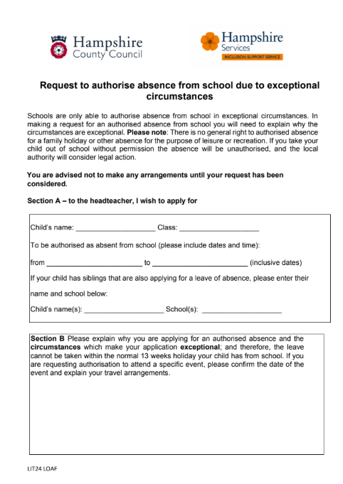
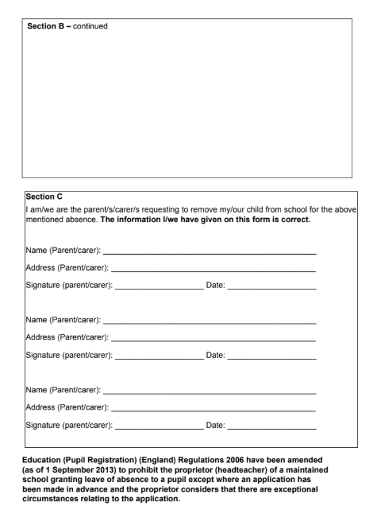
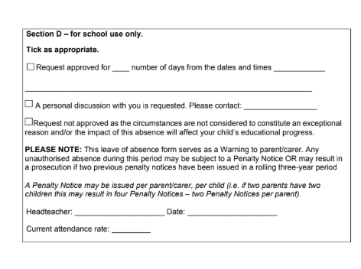

Appendix 3: Example reply to leave of absence request

Dear Parents name,
RE: Absence during term time – Child Name (Child DOB)
Thank you for your application for absence in term time for Child name. Whilst we appreciate your circumstances, St John the Baptist Primary C of E School do not approve any absences during term time unless they are due to exceptional circumstances as per the guidance from the Department of Education.
The rationale behind this decision is that the Government has provided evidence that satisfactory progress at school is highly dependent on attendance.
School Name works closely with the Inclusion Support Service and if you choose to take your child out of school for the above unauthorised leave, We will notify the local authority and further action including legal action may be considered.
Please note that such a Penalty is issued to each parent for each child taken out of school. A Penalty Notice is a fine of £80 which increases to £160 if not paid within the first 21 days. Thereafter if the Penalty remains unpaid after 28 days this may result in legal action be taken against you. Parents have a duty to ensure their child’s regular attendance at school and failure to do so is an offence under Section 444(1) of the Education Act 1996.
I have noted the dates that Child Name will be absent from St John the Baptist Primary C of E School, Dates of leave and the registers will be marked with the G code (unauthorised family holiday) for this period.

If you would like to discuss the matter further, please contact the school.
Yours sincerely

Headteacher

Appendix 4: Attendance Policy Quick Guide for Parents

Attendance Policy Quick Guide for Parents
We expect pupils to attend school for 100% of the academic year.
You can support your child to have excellent attendance by taking these steps:
- Ensure your child arrives on time for school every day and is ready to learn. Arriving after registration is recorded as an unauthorised absence. Pupils must be in school by 0850am.
- If your child appears to be only slightly ill, send them in to school. We have staff who will contact you if their condition deteriorates.
- Book any medical appointments outside of school hours. If this is unavoidable, please book for as late in the afternoon as possible and inform the school of appointments in advance.
- Supply a copy of the appointment card or hospital letter if your child has an appointment during school hours.
If your child becomes reluctant to go to school or you need help, please contact the school immediately; we are more likely to be able to work together to solve any problems if we act early.

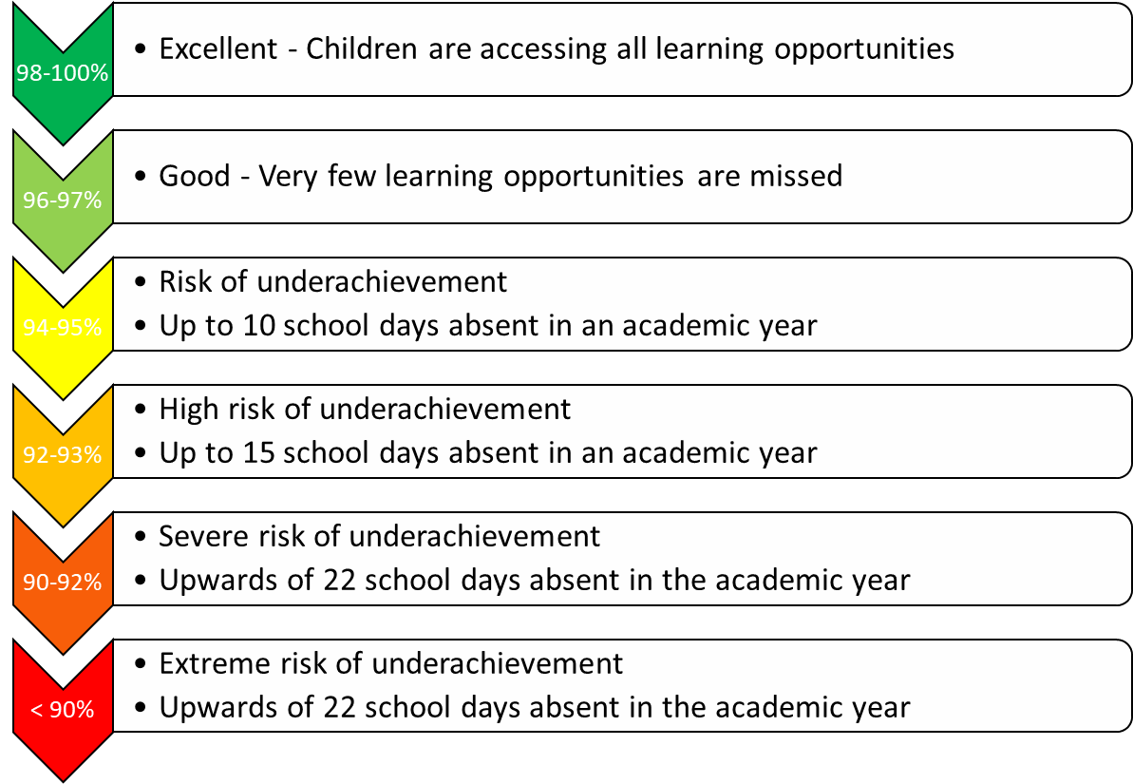
‘On the day’ absences: what should I do if my child is not ‘fit’ to go into school?
On each day your child is unfit to come to school, please report this absence by phoning or emailing the school, or popping into the office, to let us know. In the message you must leave your child’s full name, year and class and give the specific reason for absence. The information you give will be recorded on our official register.

Leave of Absence
There may be exceptional circumstances where you need to request a leave of absence for your child. Please use our ‘Leave of absence request’ form to make these types of requests. The form should be submitted in advance of the leave of absence, via office@stjohnthepbaptistprimary.co.uk , or a paper copy handed in at either office. You will receive a letter in response, to advise if the request has been granted or declined.

Punctuality
Pupils are expected to arrive on time for school in the morning and for every lesson during the day. Your child is late to school if they are not coming through the doors by 0850.

The Government remains very clear that no child should miss school apart from in exceptional circumstances and schools must continue to take steps to reduce absence to support children’s attainment. I hope we can count on your support in this matter.
Please contact the school, if you require any suport with ensruing your child’s regular school attendance.

Appendix 5: Attendance Policy Quick Guide for Pupils

Attendance Policy Quick Guide for Pupils

Roles and responsibilities:

All members of the school community at St John the Baptist Primary C of E School have roles and responsibilities in promoting and ensuring good attendance and punctuality.

Role of the pupils:

Pupils have a responsibility to themselves and others to play a positive role in the life of the school and to make the most of the education opportunities available.

All pupils will:
- Ensure that they attend school regularly and on time.
- Be aware of their current attendance record and targets (as appropriate for age).
- Be aware of the consequences of poor attendance or truancy.
- Arrive to lessons punctually.
- Not leave school without permission.
- Inform a trusted adult if they feel that they are being bullied or feel unhappy in school.

Attendance codes

The following codes are taken from Working Together to Improve School Attendance
Code | Definition | Scenario
/ | Present (am) | Pupil is present at morning registration
\ | Present (pm) | Pupil is present at afternoon registration
L | Late arrival | Pupil arrives late before register has closed
B | Off-site educational activity approved by the school.  Schools must also record the nature of the approved educational activity. | Examples of nature of activity  - 1) Attending taster days at college  - 2) Attending courses at college  - 3) Attending unregistered alternative provision arranged by the school
D | Dual registered | Pupil is attending a session at another setting where they are also registered
K | Attending education provision arranged by the Local Authority  Schools must also record the nature of the provision | • Attending courses at college  • Attending unregistered alternative provision such as, home tutoring
P | Sporting activity | The pupil is attending a place for an approved educational activity that is a sporting activity
V | Educational visit or trip | An educational visit or trip arranged by or on behalf of the school and supervised by a member of school staff
W | Attending work experience | The pupil is attending a place for an approved educational activity that is work experience provided under arrangements made by a local authority or the school as part of the pupil’s education

Code | Definition | Scenario
Absent – leave of absence
C | Leave of absence for exceptional circumstances  Generally, a need or desire for a holiday or other absence for the purpose of leisure and recreation would not constitute an exceptional circumstance | Schools must judge each application individually considering the specific facts and circumstances and relevant background context behind each request. Where a leave of absence is granted, the school will determine the number of days a pupil can be absent from school
C1 | Leave of absence for the purpose of participating in a regulated performance or undertaking regulated employment abroad | All schools can grant leaves of absence for pupils to undertake employment (paid or unpaid) during school hours
C2 | Leave of absence for a compulsory school age pupil subject to a part-time timetable | All pupils of compulsory school age are entitled to a full-time education. In very exceptional circumstances, where it is in a pupil’s best interests, there may be a need for a temporary part-time timetable to meet their individual needs
E | Excluded | Suspended or permanently excluded and no alternative provision made
I | Illness (not medical or dental appointment) | The pupil is unable to attend due to illness (both physical and mental health related). Schools should advise parents to notify them on the first day the child is unable to attend due to illness
J1 | Interview | Attending an interview for employment or for admission to another educational institution
M | Medical appointment | Attending a medical or dental appointment
R | Religious observance | The pupil is absent on a day that is exclusively set apart for religious observance by the religious body the parent(s) belong to
S | Study leave | Studying for a public examination. Must be used sparingly with revision opportunities in school
T | Parent travelling for occupational purposes | The pupil is a mobile child and their parent(s) is travelling in the course of their trade or business and the pupil is travelling with them
X | Non-compulsory school age pupil not required to attend school

Code | Definition | Scenario
Absent - unable to attend school because of unavoidable cause
Q | Unable to attend the school because of a lack of access arrangements | This is linked to transport not other access arrangements
Y1 | Unable to attend due to transport normally provided not being available | The school is not within walking distance of the pupil’s home and the transport to and from the school that is normally provided for the pupil by the school or local authority is not available
Y2 | Unable to attend due to widespread disruption to travel
Y3 | Unable to attend due to part of the school premises being closed
Y4 | Unable to attend due to the whole school site being unexpectedly closed | Adverse weather
Y5 | Unable to attend as pupil is in criminal justice detention | In police detention, remanded to youth detention, awaiting trial or sentencing, or detained under a sentence of detention.
Y6 | Unable to attend in accordance with public health guidance or law
Y7 | Unable to attend because of any other unavoidable cause | An emergency has prevented the pupil from attending. The unavoidable cause must be something that affects the pupil, not just the parent.

Code |  | Definition |  | Scenario
Unauthorised absence
G | Unauthorised holiday |  | Holiday not granted by the school
N | Reason for absence not yet established |  | Pupil is absent for an unknown reason (this code should be amended when the reason emerges, or replaced with code O if no reason for absence has been provided after a reasonable amount of time)
O | Absent in other or unknown circumstances |  | Where no reason for absence is established or the school is not satisfied that the reason given
U | Arrival after registration |  | A pupil has arrived late after the register has closed but before the end of session.

Code | Definition | Scenario
Administrative Codes
Z | Prospective pupil not on admission register | To enable schools to set up registers in advance of pupils joining the school to ease administration burdens.
# | Planned whole school closure | Whole school closure due to half-term/bank holiday/INSET day/use of whole school as polling station

